Case Study | Swanage Coastal Management
Key terms | Abrasion  Attrition  Deposition  Hydraulic Action  Longshore Drift
Features of the South Coast of England (Dorset) | Feature 1  Durdle Door (arch) | Feature 2  Landslide at Barton on Sea |  | Feature 3  Swanage Bay (Headland and Bay)
 | 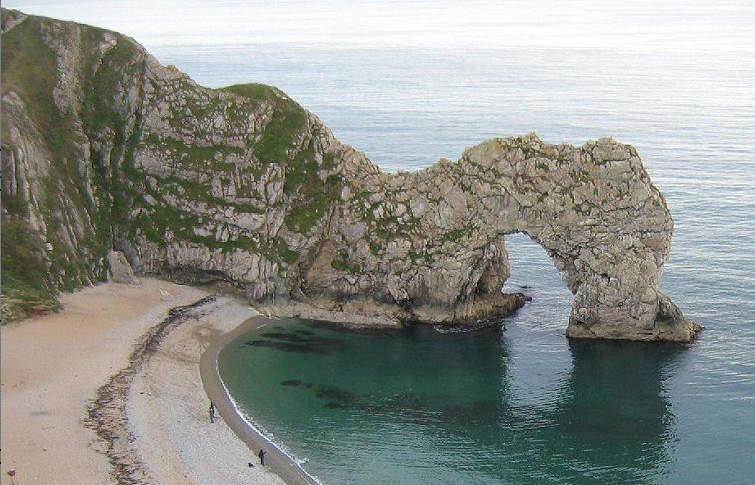 | 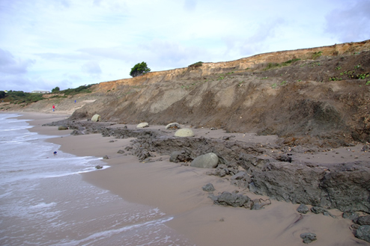 |  | 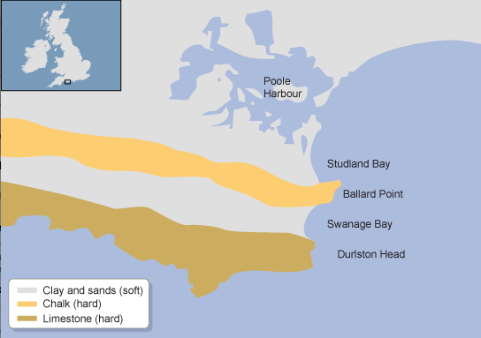
 | Key terms:  attrition abrasion hydraulic action longshore drift arch stack stump | Key terms:  Permeable impermeable water build up slip zone less friction rotational slip |  | Key Terms:  Hard rock soft rock abrasion attrition longshore drift
 | Explain how it is made | Explain how it is made |  | Explain how it is made
What is the Banjo Pier and why was it built in Swanage? | Flood Alleviation  Feature on the Beach
What is the impact of the Banjo Pier? | Benefits |  | Costs
 | Reduced flood risk  Tourist Attraction on the beach |  | Blocks Longshore drift  Increase Landslides north of the pier
How should the coastline at Swanage be managed in the future?

