Thomas Tallis Geography Department

How to get full marks on the 8mark question.

Theme1: Challenges of living in a built environment.

To be successful at case studies you must have the three golden components:

How is your Case study marked?

Level and Mark | Criteria
Level 1  (1 or 2 marks) | Basic description AND/OR explanation.
Level 2  (3 or 4 marks) | Must have named a real case study.  Some description AND/OR explanation.
Level 3  (5 or 6 marks) | Must have included description AND explanation.  Must have elaborated description and explanation.
Level 4  (7 or 8 marks) | Excellent example with some detail.  Wholly accurate – no duff information!  Well elaborated description and explanation.

June 2011 question E:

- Name and locate an area with in a city where housing has been improved.

This is the first section of the exam question Golden component 1!

What case studies would you use for this?
Case studies to use | Location (global, national)  Big picture – whole city | Location (regional/local)  Detailed – specific area
Rio De Janerio (LEDC) | City located on Brazil’s SE coast in South America | Favela Rocinha is located in the Southern zone of the city, built on a steep hillside overlooking the City of Rio De Janerio, 1 km from the beach.
London Docklands (MEDC)

Can you fill in the Docklands location using the example above?

Describe how the local authority has improved the housing in this area?

This is the second section of the exam question Golden component 2!

Case study specifics:
Case studies to use | Schemes used by the local authority | Key words to include
Rio De Janerio (LEDC)
London Docklands (MEDC) | Enterprise zone created in 1981 with an organization known as LDDC to control the enterprise zone. Companies were given incentives to move to this zone. By encouraging industry the LDDC aimed to bring land and buildings into use, improve the environment and provide better housing and facilities. This was achieved by cash grants and tax rebates to businesses, building small industrial parks, encouraging new housing projects on old derelict land and installing new transport links such as the DLR, London city airport and Jubilee line. These encourage people into the area as new housing was provided with access to transport links and amenities. | Enterprise Zone  Government  Redevelopment  Incentives  LDDC  Tax rebates  Grants

Now have a go at filling in the case study section for Rio De Janerio.

Explain why the improvements were needed?

This is the third and final section of the exam question. Golden component 3!

Case study specifics:
Case studies to use | Schemes used by the local authority | Key words to include
Rio De Janerio (LEDC)
London Docklands (MEDC) | The redevelopment was needed because in the inner city because of Urban Decay. High unemployment (24%) due to closures of industries associated with the docks had left the area deprived, with 15% of families living in the area on benefits. Those who could afford to left the area, leaving behind the most disadvantaged in poor quality housing that was poorly looked after. With businesses closing down in the area new housing development programs were unlikely to be developed in an area of economic decline. With the Enterprise zone set up, it improved job opportunities in the area by creating new industries allowing for housing developers to be interested in old derelict land. Those who were previously out of work could find jobs in the new industries and afford to move into the newly developed houses (71% of these are for owner occupation) in their local area. | Enterprise Zone  Urban Decay  Unemployment  Inner City  Redevelopment  Economic decline  Derelict land

Complete the Rio De Janerio case study section

WHY: Why wasn’t the London docklands a good case study to use? Look at the mark scheme for the question. Why wouldn’t this person have accessed full marks?
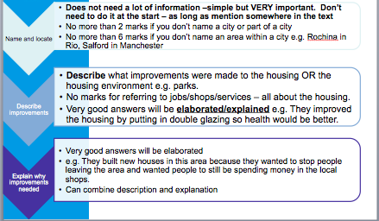

Which London Case study should they have used?

Now see if you can plan an 8 mark question by splitting into three sections:

Identify an Urban area that experiences inequality.
Describe the inequalities and explain why they occur.
Explain the solutions that can be put in place to address the issue.

Components of the question: | RIO DE JANERIO
1 Location | (Global/national) big picture – whole city | (Local/regional) Detailed – specific area
2 Description | What are the inequalities?  Why do they occur? | Key words to include:
3 Explaination | What are the solutions?  How do they work to solve the issues? | Key words to include:

Access to services and changing service provision.
2.1 How are services distributed in urban areas?
2.2 What changes are taking place in service provision?
2.3 Why are these changes taking place?
2.4 How and why might these changes benefit or disadvantage groups of people? 2.5 How and why does access to services in urban and rural areas vary between different groups of people?

BARCELONA CASE STUDY

Services in Barcelona, Spain

Barcelona is situated in north – east Spain, on the Mediterranean coastline. Barcelona is 500km North-East of Madrid which is the capital city of Spain. Like most MEDC cities Barcelona receives immigrants from LEDC nations understandably looking to improve their Standard of Living and Quality of Life.
The location of Barcelona, Spain.
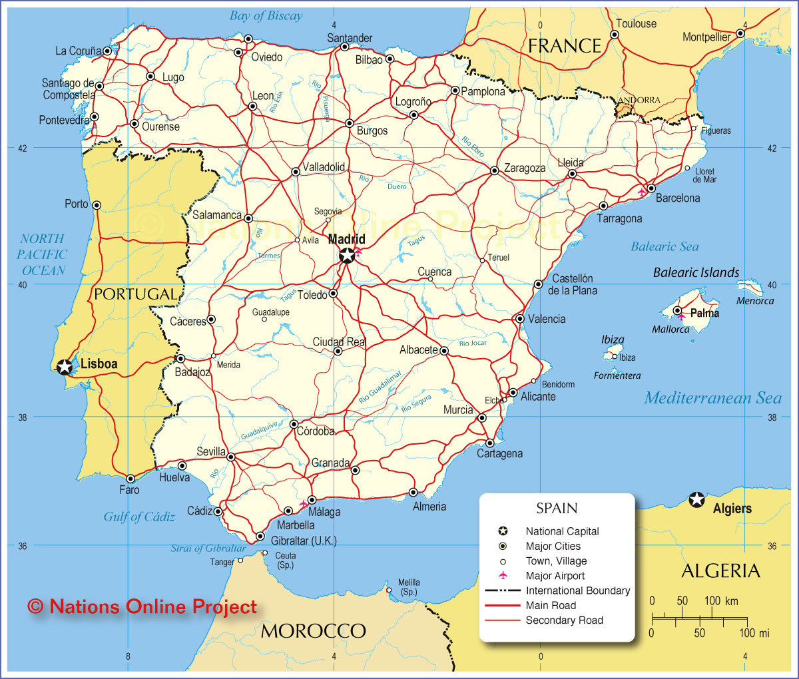

Traditionally many of these migrants come from Muslim nations such as Pakistan and Morocco and the Muslim influence can be seen through areas of the city.
Muslim immigrants coming to Barcelona with little money generally tend to live around the centre of the city in the Ciutat Vela, in an area known as El Raval.
This is because…
- Accommodation is often cheaper as it is lower quality.
- They like to live with people from similar cultural backgrounds so it is easier to socialise.
- They need the services on offer in these areas that have built up over time e.g.

- Halal butchers (Muslims can only eat blessed Halal meat).
- Places offering cheap international calls to keep in touch with family & friends.
- Shops selling clothes suited to their fashion/culture.
- Mosques for worship as this is very important to Muslim people.
Islamic services in Barcelona

Results of this…
Often the inner city areas have different service provision than the suburbs of the city, in the suburbs there are generally fewer immigrants and the population has a different age structure, for example there are fewer youth centres in the suburbs as there are generally fewer younger people.
The standard of Living of people in the Ciutat Vela is often lower as they have lower paid jobs and therefore can’t afford as many luxuries. As a result the quality of Life deteriorates as there is often more crime, overcrowding due to cheap houses and less open space.

The image below shows a typical apartment in El Raval.

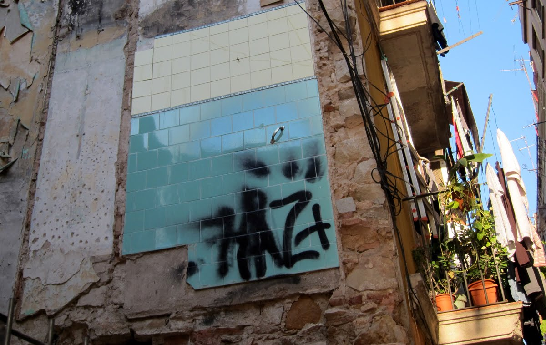

The image below shows a typical apartment in the suburbs Barcelona.

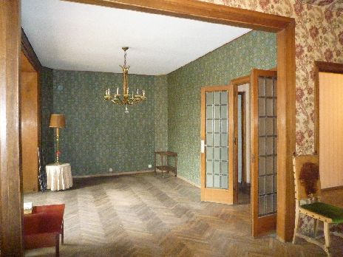

The northern Suburbs of Barcelona are much more developed than the Ciutat Vela and therefore are much more expensive to live in.

- Sarria Sant Garvasi, Nou Barris and Horta Guinardo are all suburbs in the north of Barcelona.

- These suburbs will contain many larger detached & higher quality properties. People living in these suburbs will be wealthier and many will have had a good education and enjoy a higher standard of living due to their higher incomes as 36.7% of the population have higher qualifications & will therefore work in better paid professional jobs.

- Many of the families living in the outer suburbs will own at least one car.

- Quality of life will be better in the suburbs as the people living there will be subject to less crime, have more open space and will have a longer life expectancy as they can access better healthcare.

A map showing the districts of Barcelona.

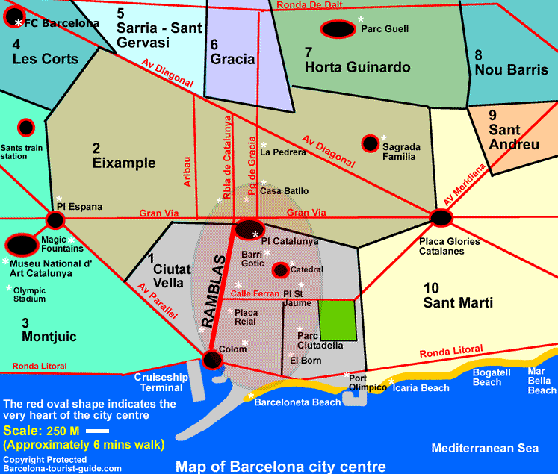

Barcelona
Summary of case study:

Marking your answers:

What mark do you think the following two answers got to the question below?
i. Name and locate an area within a city where housing has been improved.
ii. Describe how the local authority has improved the housing in this area.
iii. Explain why the improvements were needed.

- Bute Town in Cardiff Bay
- The local authority knocked down the old houses and built new modern high rise flats. High rise flats take up less space so you can build more to cope with the increasing population. They are also cheaper to build. They also developed services. They made a regular bus root built shops added leisure activities like the red dragon centre they builit up the surrounding area. These improvements were needed because the old houses were un-safe falling apart they did not have modern amenities like central heating etc. they were not of a good enough standard anymore there also wasn’t a good access to services. There wasn’t a regular bus root ore many activities to do in your leisure time the whole area needed modernising. To attract new business to the area and have to make people want to move there.

WWW:____________________________________________________________________________________________________________________________________________________________________________________________________________________________________________________________________________________________________
EBI:________________________________________________________________________________________________________________________________________________________________________________________________________________________________________________________________________________________________________
Total score: ____________________ Level banding: _______________________
Answer 2:
An area which people have migrated from is in the LEDC of South Africa. It is called Limpopo. It has a population of around 90,000 people - 90% of which live in the rural areas. Many people from Limpopo migrated to another province in South Africa, it’s neighbour Guateng.
The migration has had many effects on the area and it’s people. Firstly, it has lost its most skilled, brightest and youngest workers which means elderly, women and children who struggle to grow food so there is malnutrition. Also, families have been left separated and in many cases children have been left to raise themselves.
However, often the migrants are economic migrants looking for better jobs and opportunities in the cities. These people may send remittances home for their families or money to invest in rural community projects to develop their home area. Also the migrants may bring back new ideas, experiences and farming techniques. However, if they are circular migrants (return to Limpopo in the best farming season) they could bring back illnesses and sexually transmitted diseases that will spread round the community quickly.
There are many reasons why people migrate from rural to urban areas. The rural areas lack sanitation, schooling opportunities or healthcare centres that many would want to experience and have the privilege of having in the urban area. These are called push factors. There are also pull factors to Guateng, for example, the higher wages, the faster paced lifestyle it offers.

WWW:____________________________________________________________________________________________________________________________________________________________________________________________________________________________________________________________________________________________________
EBI:________________________________________________________________________________________________________________________________________________________________________________________________________________________________________________________________________________________________________
Total score: ____________________ Level banding: ______________________

More practice questions for you to try at home:

- Name and locate an area that experiences the process of urbanisation
- Describe the causes of Urbanisation
- Explain the impacts it has on different areas.

- (i) For a service in a town or city:
  - Name the service.
  - Describe the distribution of this service within the town or city.
  - Explain how access to this service varies for different groups of people.

- (ii) For a town or city where there are variations in quality of life.
  - Name and locate the town or city.
  - Describe how the quality of life varies in different parts of the town/city.
  - Explain why quality of life varies between these places.

  - Name and locate an area within a Less Economically Developed Country (LEDC) from which people have migrated.
  - Describe the effects on the area from which people have migrated.
  - Explain why they migrated.

GOOD LUCK IN THE EXAM!

