Name: ___________________________________

YEAR 11 Geography Revision work booklet
Revision pack 4:

Paper 2: UK Geographical Issues
The UK’s evolving physical landscape

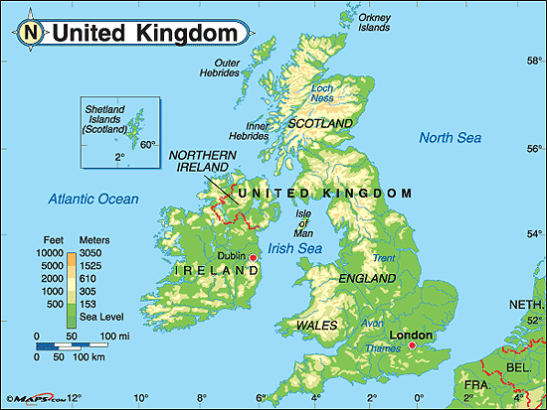

Key terms word search
Complete the key terms word search.
S E H N C M D F E T Y S F V N N J W E H
E D D E L O K I N G W G A T O C E D L Y
D R E U V K N A S A R B O I T A J V B D
I F N L J I D S S C U A S L T B E M A R
M B T A Z R T H T A O A H H O L M E E O
E M A I O R H C G R R R E C O E M C M G
N Y U C O K Y V U B U R D C S I G L R R
T A N A K O D G A R I C I A T I O W E A
R O K L K W R P R N T T T G N N D A P P
C G S G M P A R G O Y S A I G T H V M H
N J A W C U U S P P Y L E S V R X E I W
F W O N R N L T H W B N H D G E B S O O
J D E P O S I T I O N O E G K U W M M M
X F R G A U C C P Y R A U T S E I A F F
J C A U M E A N D E R F D J J M E U V Z
K O P W C L C Z D N O I T I R T T A U E
O Y E F D R T R Z G V L K H O K M D Q H
N O I T A R I P S N A R T U R U U R F B
M Y M I V F O Y U Q H R M F A H J M O U
V L U Y T X N A L L U V I U M D K L O O

ABRASION ALLUVIUM ATTRITION BACKWASH CONCORDANT CONSTRUCTIVE-WAVE DEPOSITION DESTRUCTIVE DISCHARGE DISCORDANT ESTUARY GEOLOGY GLACIAL GROYNE HYDRAULIC-ACTION HYDROGRAPH IMPERMEABLE LAG-TIME LONGSHORE-DRIFT MEANDER PERMEABLE SEDIMENT SWASH TRANSPIRATION VELOCITY WAVES WEATHERING

Key words and definitions:
Key word | Definition
Alluvium | Fine sediments which are deposited by rivers
Attrition | A type of erosion where rocks/pebbles are carried by rivers or waves and worn down as they collide with each other so that they become smaller and rounded
Backwash
Bar | An area of sea, curved in shape which has been eroded between two headlands
Beach replenishment
Berm | A ridge of sediment found towards the back of a beach
Biological weathering
Bio physical weathering | The process of rocks being physically broken up by living things such as tree roots.
Clitter slope | The trail of deposited rocks from the action of freeze thaw weathering on tors
Concordant coasts
Constructive wave
Contour | Line on a map joining places of equal height above sea level
Corrosion | Chemical erosion caused by the dissolving of rocks and minerals by water.
Cove
Delta
Deposition
Destructive wave
Discharge | The amount of water flowing in a river, made up of its volume and speed, and measured in cubic metres per second.
Discordant coast
Drainage basin | The area of land drained by a river and its tributaries
Erosion
Estuary | The mouth of a river which gets very wide as it merges with the sea, it is tidal e.g. Thames Estuary
Fetch | The distance a wave has travelled towards the coastline over open water, the longer the fetch the more powerful the wave.
Freeze thaw weathering
Gorge
Gradient | How steep a slope, river channel or valley is.
Groyne
Hard engineering
Hydraulic action
HEP (hydro-electric power)
Hydrograph | A graph showing changes in a river’s discharge and rainfall over time.
Impermeable
Infiltration
Integrated Coastal Zone Management (ICZM) | A way to manage the coast and the land behind it sustainably, by involving everyone involved in using it.
Lag time
Landslip
Lateral erosion
Longshore drift
Meander | A bend in a river
Oxbow lake
Permeable | Allows water to pass through e.g. chalk
Prevailing wind | Direction in which the wind blows most frequently
Runoff
Saltation | Where sediment transported by rivers/waves is being bounced along the bed/sea floor
Sediment load
Shoreline management plan (SMP) | A plan which assesses the risks to a piece of coastline and how to manage these.
Slip-off-slope
Solution | The process where some rock minerals slowly dissolve in water, which is slightly acidic.
Sub-aerial
Surface run-off | Water running across the lands surface into rivers
Swash
Traction | The transport of sediment along a river bed or the sea floor through a rolling action
Transpiration
Tributary
V shape valley
Velocity
Wave cut platform
Weathering
UK Physical landscape
Rock types complete the gap fill to identify the different types of rocks.
_________________ _____________________ __________________
I am created by volcanic activity when magma or lava cools, forming rocks made of crystals that are usually hard. Granite is one example of ____________________ rocks.
I am an existing rock that has been changed by extreme pressure and heat. I have layers or bands of crystals and am very hard rock. Slate and schists are examples of ________________ rocks.
I am formed of small particles that have been eroded, transported and deposited in layers, sometimes I contain the remains of plants and animals. Limestone is an example of a ___________________ rock.
Geological map of the UK and Ireland
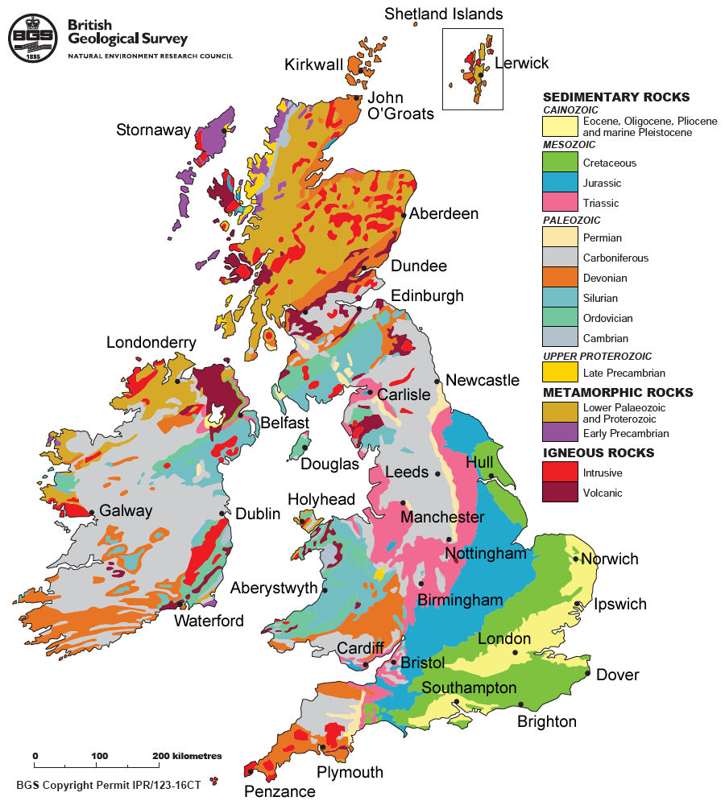
Which areas of the UK have igneous rocks? ______________________________________________________________________________________________________________________________________________________
Explain why the south east of England only have sedimentary rocks? _________________________________________________________________________________________________________________________________________________________________________________________________________________________________
The UK and glaciation.
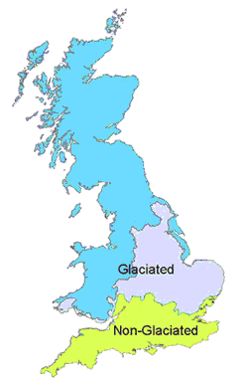
18,000 years ago ice covered about 30 per cent of the land in the world. In Britain, ice covered land as far as the Bristol Channel. During the last ice age the temperature remained below 0°C which allowed the ice to remain on the land all year. Weathering
The predominant process is freeze-thaw weathering. Freeze-thaw describes the action of glacial meltwater on joints, cracks and hollows in rock. When the temperature reaches freezing point, the water inside cracks freezes, expands and causes the cracks to widen. When the temperature rises, the water thaws and contracts. This eventually causes rocks to break up. For freeze-thaw to take effect, the air temperature needs to fluctuate around freezing point.
Freeze-thaw weathering = angular rock fragments.
Look at the images below. Decide which of these features are formed from glaciation or from rivers.
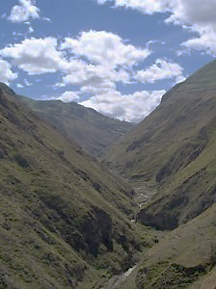
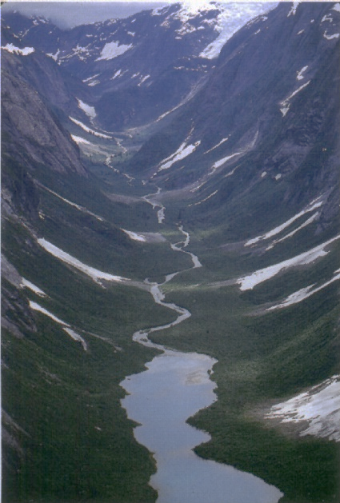
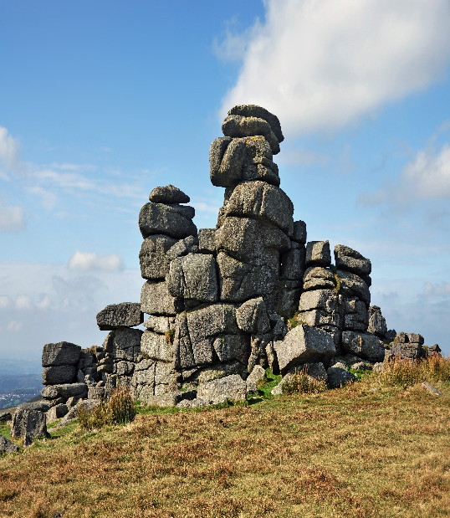

____________________ _________________________ _______________________
____________________ _________________________ _______________________

Why does Scotland have a different rock type to England and Wales? ____________________________________________________________________________________________________________________________________________________________________________________________________________________________________________________________________________________________________________
Malham Cove: Carboniferous Limestone:
Read through the information. Highlight information about the rock type and how Malham cove was formed.
The geology at Malham cove is Carboniferous Limestone. This was formed during the Carboniferous period between 250 and 350 million years ago. Scientist have determined the age of this rock through carbon dating the fossilised small creatures that are part of the limestone.
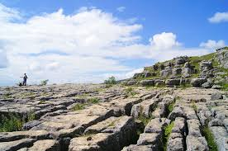
Carboniferous Limestone formation:
Carboniferous limestone is a sedimentary rock. This means it is made up of layers of small rock particles and other material, including small skeletons. When this limestone was formed 250 to 350 million years ago, the UK was covered by tropical seas, like the Barrier Reef in Australia today. As the tropical fish and corals that lived there died, they sank to the bottom of the sea floor, forming horizontal layers called strata.
Over time, this material at the bottom of the sea was turned into rock. This occurred due to two processes:
As the skeletons fell, they crushed those beneath, eventually squeezing out water and compacting them into rock.
Calcium carbonate (a natural compound found in sea water) crystallised around the fragments. This cemented them together and even preserved some fossils in tact. This is why you can see some shells in the limestone around Malham cove today.
Other Malham Cove Rock Strata:
After the creation of Carboniferous limestone 250 to 350 million years ago, other rock strata were deposited over the limestone, for example sandstone and shale (both sedimentary rocks). The most resistant rock is Millstone grit, which makes up the highest points of Malham cove as it is the most resistant. This means it does not erode easily. The shale and sandstones underneath this millstone grit are less resistant = erode quicker.
Key terms:
Carbon Dating: using radioactive tests to find the age of rocks which have living material in.
Erosion: means wearing away the landscape.
Carboniferous: a geological time period that lasted from 250 million – 350 million years ago.
Strata: horizontal layers of rock.
Sedimentary: one of the three rock types. These rocks have layers formed from small particles of rocks and other material.
1. How has the Malham cove limestone moved for under the sea near the equator to where it is today? _________________________________________________________________ ____________________________________________________________________________________________________________________________________________________________________________________________________________________________________________________________________________________________________________
2. Why is carbon dating not used for other rock types (igneous & metamorphic)? _________________________________________________________________________________________________________________________________________________________________________________________________________________________________
3. Explain one way in which geology has shaped the UK’s physical landscape. (2 marks) ____________________________________________________________________________________________________________________________________________________________________________________________________________________________________________________________________________________________________________

How have humans changed the physical landscape? Upland and lowland regions.
Look at the two images. Which location would you choose to build your home and move your people to? Why? Give reasons for your answer.
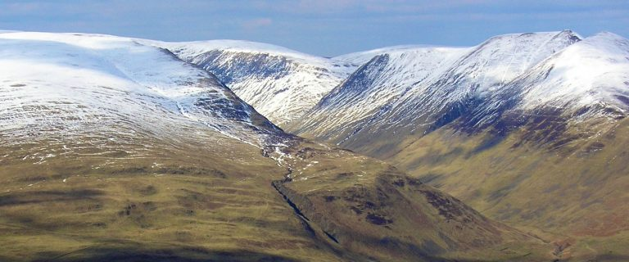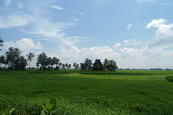
_____________________________________________________________________________________________________________________________________________________________________________________________________________________________________________________________________________________________________________________________________________________________________________________________________________________________________________________________________________________________________________________________________________
Skills Checker
(a) Study Figure 1.
(i) Identify area X.
  - An upland area of Scotland
  - A lowland area of Wales
  - An upland area of Wales
  - A lowland area of Scotland
(b) Explain one way in which tectonics has affected the physical landscape of the UK. (2) ________________________________ ________________________________ ________________________________ ________________________________ ________________________________

