Name: ___________________________________

YEAR 11 Geography Revision work booklet

Revision pack 4:

Paper 2: UK Geographical Issues

The UK’s evolving physical landscape

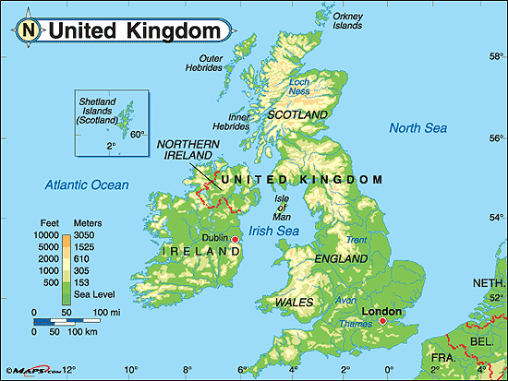

**Coasts**

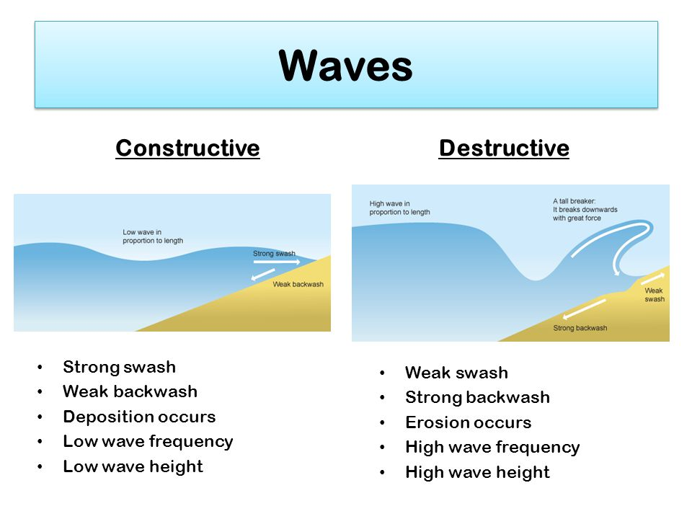**Complete the annotations for a destructive wave.**

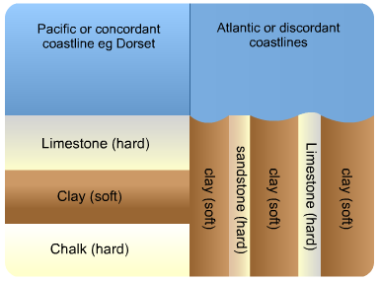

**Explain the differences between concordant and discordant coastlines (4 marks) _______________________________ _______________________________ _______________________________ _______________________________ _______________________________ _______________________________ _______________________________**

**Explain why constructive waves are more likely to deposit material than destructive waves (4) __________________________________________________________________ ____________________________________________________________________________________________________________________________________________________________________________________________________________________________________________________________________________________________________________**

**Read through the information highlight key terms to help aid your explanation of the formation of headlands and bays.**

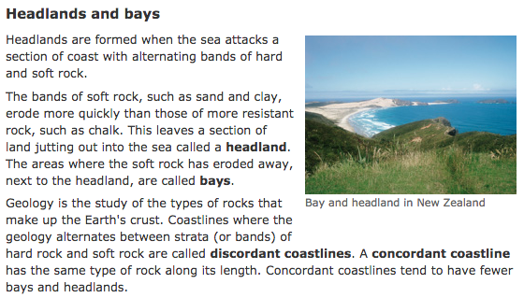

**Types of coastal erosion**

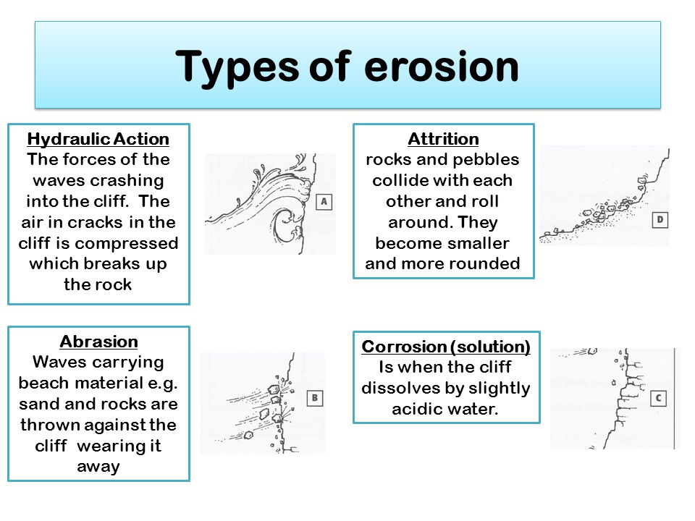

**Explain the formation of headlands and bays (4) _______________________________________________________________________________________________________________________________________________________________________________________________________________________________________________________________________________________________________________________________________________________________________________________**

**What influences the rate of erosion?**

* Length of fetch: the longer the fetch the greater the time for waves to collect energy from the wind
* Depth of sea: the gentle gradient of the sea bed causes friction and lower waves with less erosive power. A steeply shelving beach leads to higher waves and greater erosion
* Rock structure/ resistance: strength of rock influences the rate of erosion. Fault lines offer weakness to be rapidly eroded
* Cliff height: the higher the cliff the more weight is over a wave cut notch. The notch will not be able to support the weight above it for long and it will collapse faster than smaller cliffs
* Wave steepness: very steep destructive waves have more energy, and greater erosive power than gentle constructive waves
* Breaking point of the wave: most energy is released and erosion caused if a wave breaks at the foot of a cliff. If the wave breaks before it reaches the cliff then less energy is transmitted

|  |  |  |
| --- | --- | --- |
| **Site (cliff Height)** | **Retreat over 10 years (metres)** | **Cause** |
| **Happisburgh, Norfolk (7-10 metres)** | **90** | **Failure of coastal defences** |
| **Sidestrand, Norfolk (60 metres)** | **20** | **Large, infrequent landslides** |
| **Aldbrough, Holderness, Yorkshire (17 metres)** | **26** | **Small, frequent landslides; storm damage** |

**Exam question:   
Study table 1. Calculate the mean rate of erosion per year for each location (3)  
Happisburgh ___________________________**

**Sidestrand _____________________________**

**Aldbrough _____________________________**

**Explain the reason for the high amount of coastal erosion at one location (4) ___________________________________________________________________________ ______________________________________________________________________________________________________________________________________________________**

**Explain how fetch changes wave height and energy (4) ____________________________________________________________________________________________________________________________________________________________________________________________________________________________________________________________________________________________________________**

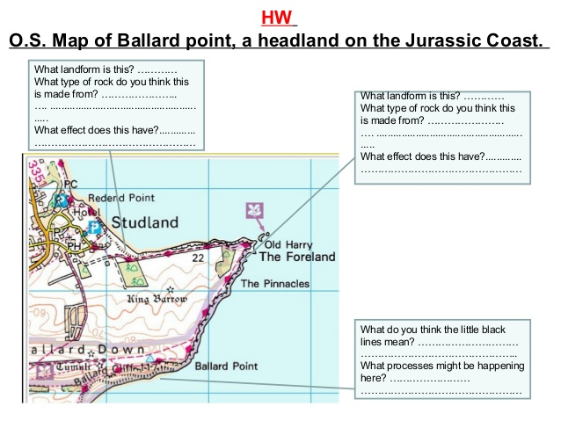

**Match the weathering definitions**

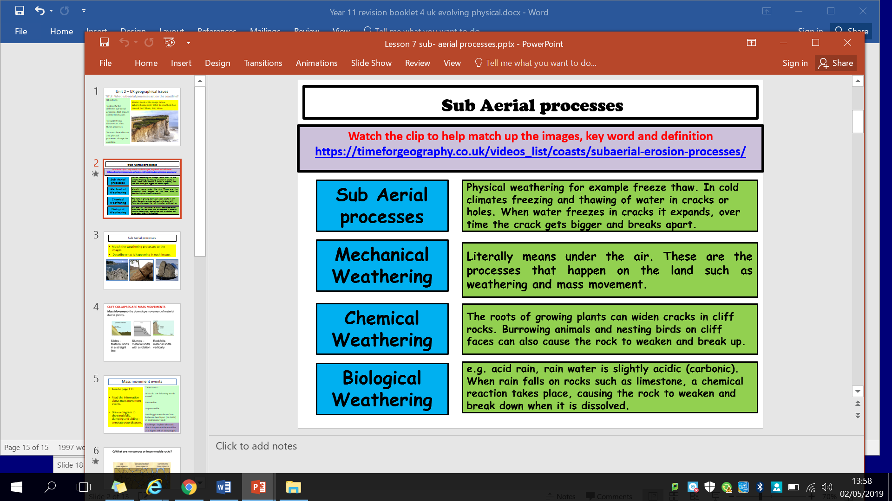

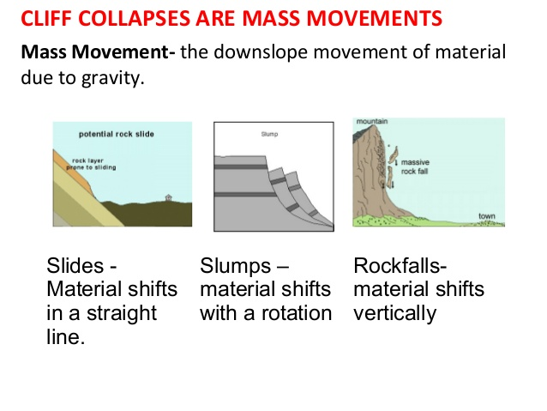

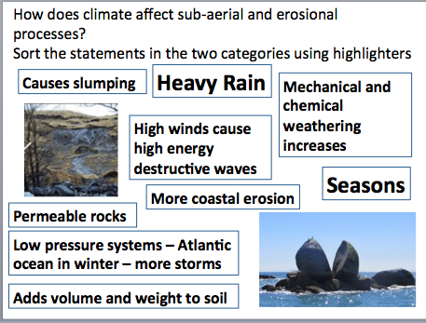

**Exam questions:**

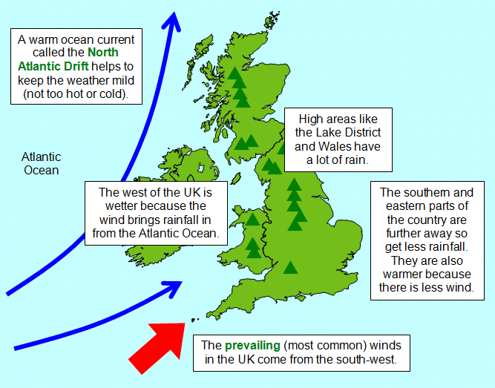1. What direction do our prevailing winds come from? __________________________

2. What direction are they travelling in? __________________________

3. Why does the UK get higher rates of erosion in the winter months than in the summer months?__________________ _________________________ _________________________

_________________________ _________________________ _________________________ _________________________

4. How do prevailing winds affect the rate of erosion along coasts of the UK (4) ____________________________________________________________________________________________________________________________________________________________________________________________________________________________________________________________________________________________________________

**To what extent does climate affect coastal erosion rates (8)**

Top tips – the question is asking you to explain how climate affects coastal erosion rates, but also what other processes affect this e.g. geology, wave type and weathering processes. Remember to include all and then give a final paragraph stating how far you think climate affects coastal erosion.

Remember to include key terms in your writing.

e.g. Sub – aerial, prevailing winds, seasons, heavy rain, winter, low pressure systems, mass movement, mechanical, biological and chemical weathering.

___________________________________________________________________________________________________________________________________________________________________________________________________________________________________________________________________________________________________________________________________________________________________________________________________________________________________________________________________________________________________________________________________________________________________________________________________________________________________________________________________________________________________________________________________________________________________________________________________________________________________________________________________________________________________________________________________________________________________________________________________________________________________________________________________________________________________________________________________________________________________________________________________________________________________________________________________________________________________________________________________________________________________________________________________________________________________________________________________________________________________________________________________________________________________________________________________________________________________________________________________________________________________________________________________________________________________________________________________________________________________________________________________________________________________________________________________________________________________________________________________________________________________________________________________________________________________________________________________________________________________________________________________________________________________________________________________________________________________________________________________________________________________________________________________________________________________________________________________________________________________________________________________________________________________________

|  |  |
| --- | --- |
| WWW | EBI |
|  |  |

**Coastal transportation**

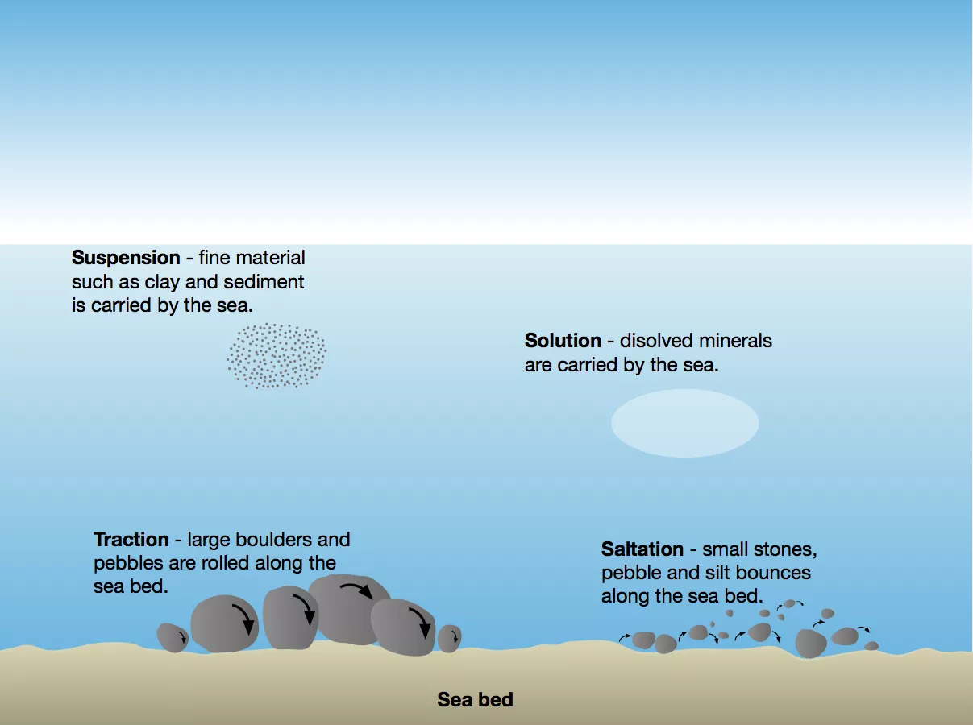

**Longshore drift**

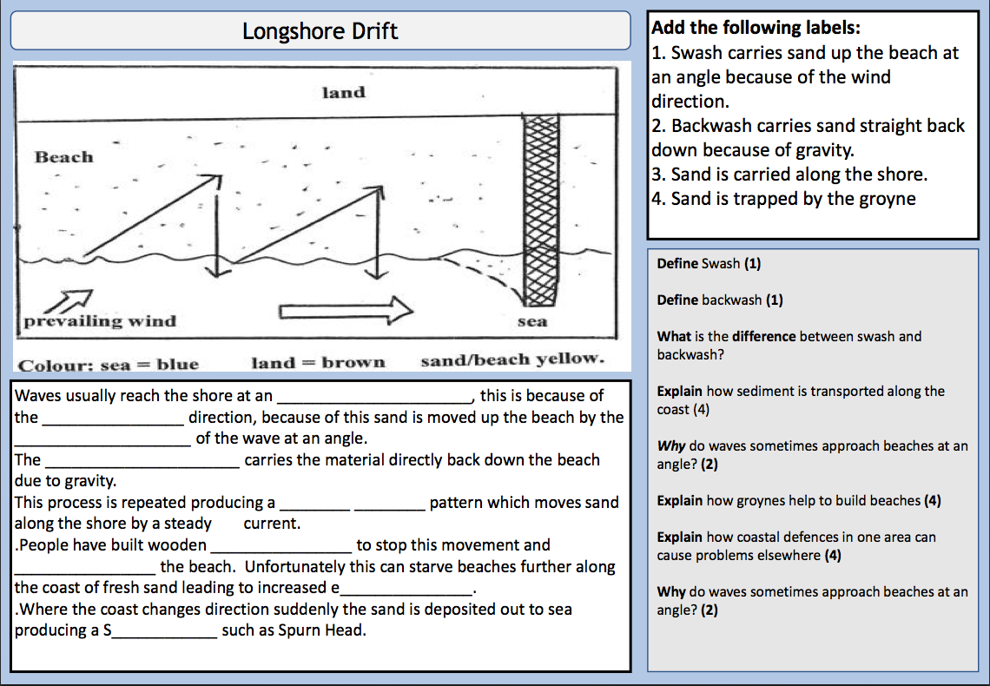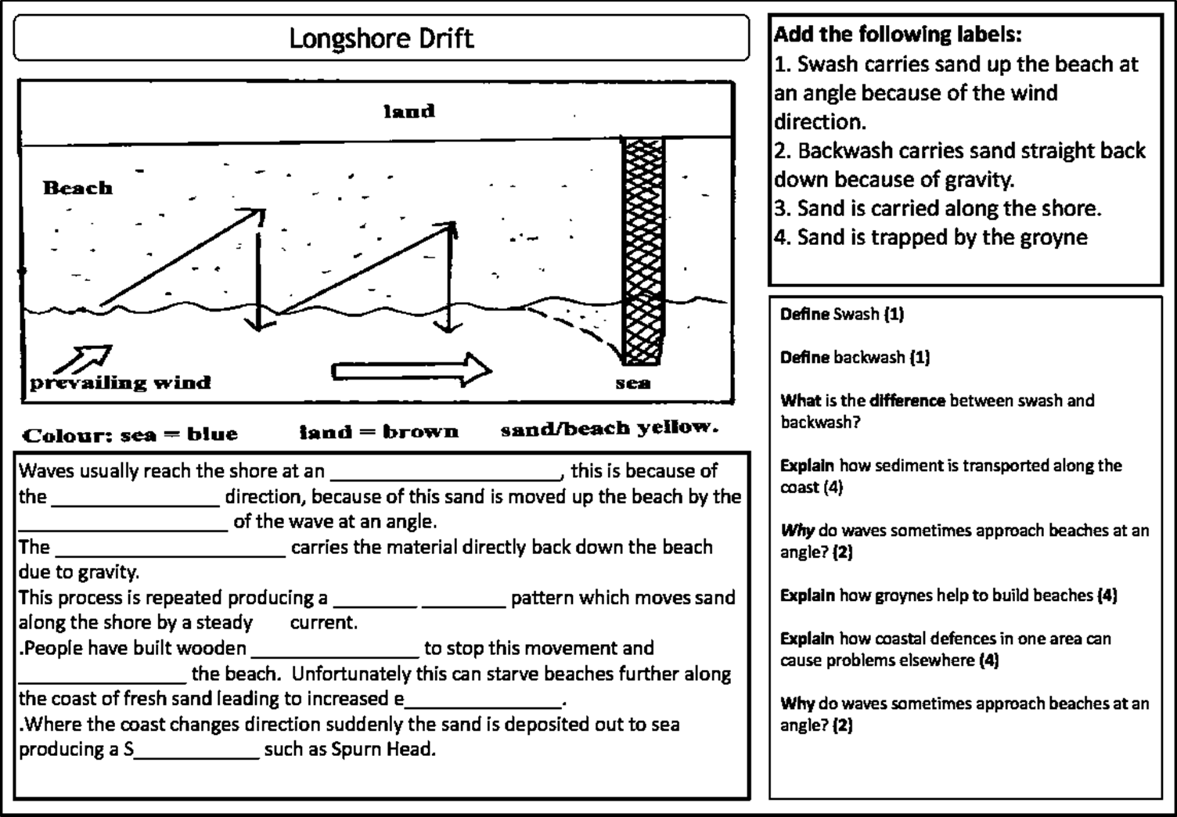

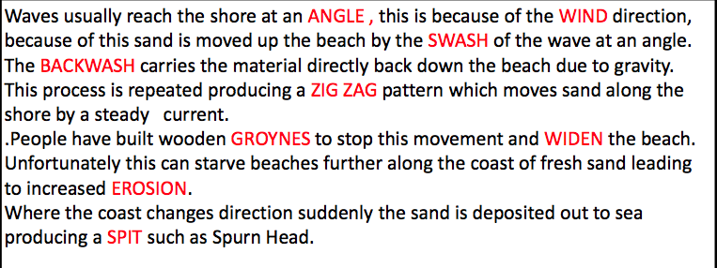

**Explain how sediment is transported along the coast (4)**

**____________________________________________________________________________________________________________________________________________________________________________________________________________________________________________________________________________________________________________**

Using the words in the word box, explain how a spit is formed.

Longshore drift transports sediment along the beach. Longshore drift is … _________________________________________________________________________________________________________________________________________________________________________________________________________________________________

When the material reaches the end of the coastline (for example the coastline changes direction)… _________________________________________________________________ ______________________________________________________________________________________________________________________________________________________The fast flowing water of the river estuary means that… _____________________________ ______________________________________________________________________________________________________________________________________________________

When the wind changes direction… _____________________________________________ ______________________________________________________________________________________________________________________________________________________

Behind the spit in calm, sheltered water a _____________ __________________ is formed.

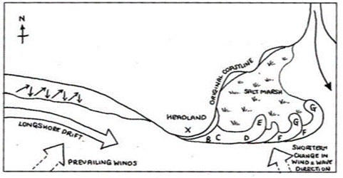

Word box:

Deposition

Secondary wind

Salt marsh

Energy

Prevailing wind

Longshore drift

Sediment

River estuary

Hooks

**Explain the formation of the picture below (4)**

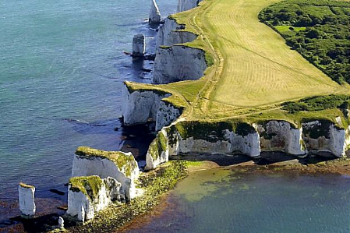**­­­­­­­­­­­­­**_____________________________________________ _____________________________________________ _____________________________________________ _____________________________________________ _____________________________________________ _____________________________________________ _____________________________________________

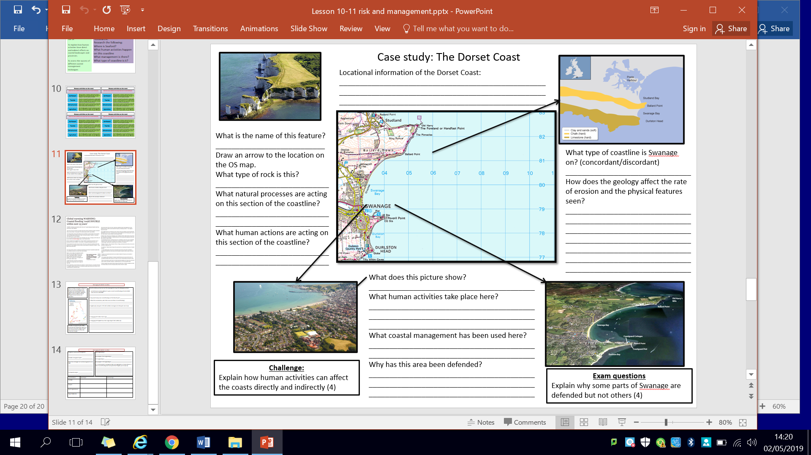

**Management techniques for coastal zones**

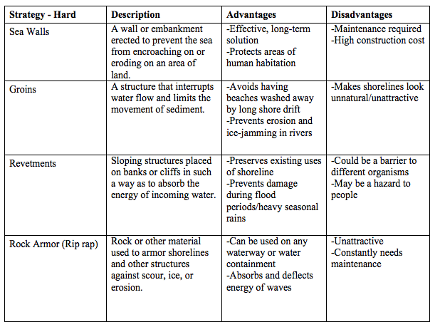

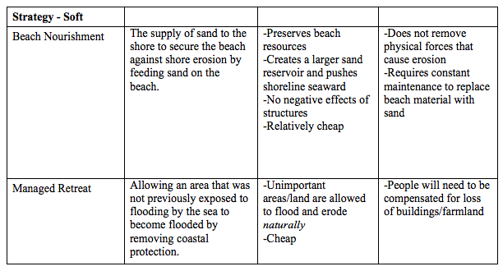

**Explain why groynes can reduce coastal erosion (2)**

_________________________________________________________________________________________________________________________________________________________________________________________________________________________________

**Rivers**

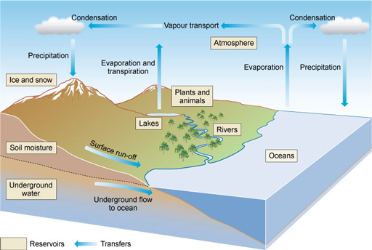

What does this model show? __________________ __________________ __________________ Why is this important when studying rivers? __________________ __________________ __________________ __________________ __________________ __________________

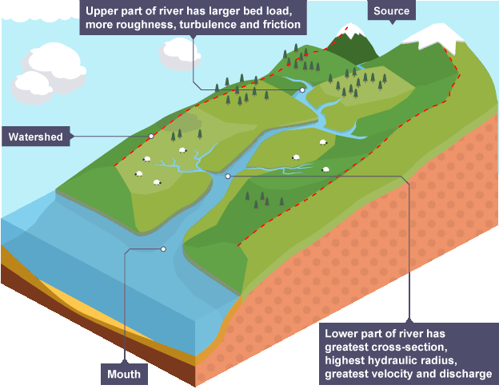

This is a drainage basin.

Describe how the river changes from source to mouth ______________ ____________________ ____________________ ____________________ ____________________ ____________________ ____________________ ____________________ ____________________ ____________________ ____________________ ___________________________________________________________________________________________________________________________________________________________________________________________________________________________________________________________________________________________________________________________________________________________________________________________________________________________________________________________________________________________________________________________________________________________________________________________________________________________________________________________________________________________________

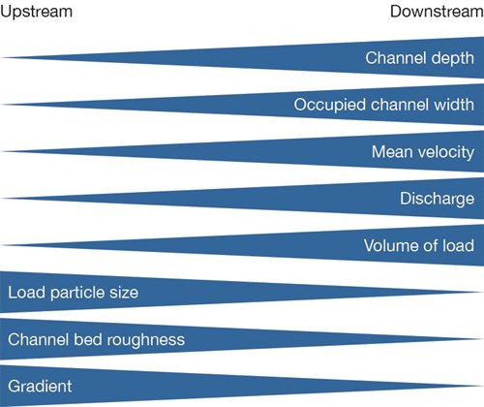What is the name of this model?

Using the model explain why particle size decreases as a river moves from source to mouth (4) ________________ _________________________________ _________________________________ _________________________________ _________________________________ _________________________________ _________________________________ _________________________________ _________________________________ _________________________________

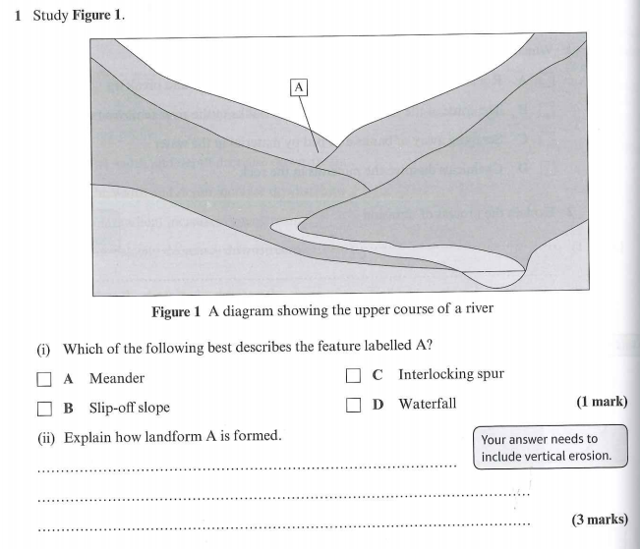

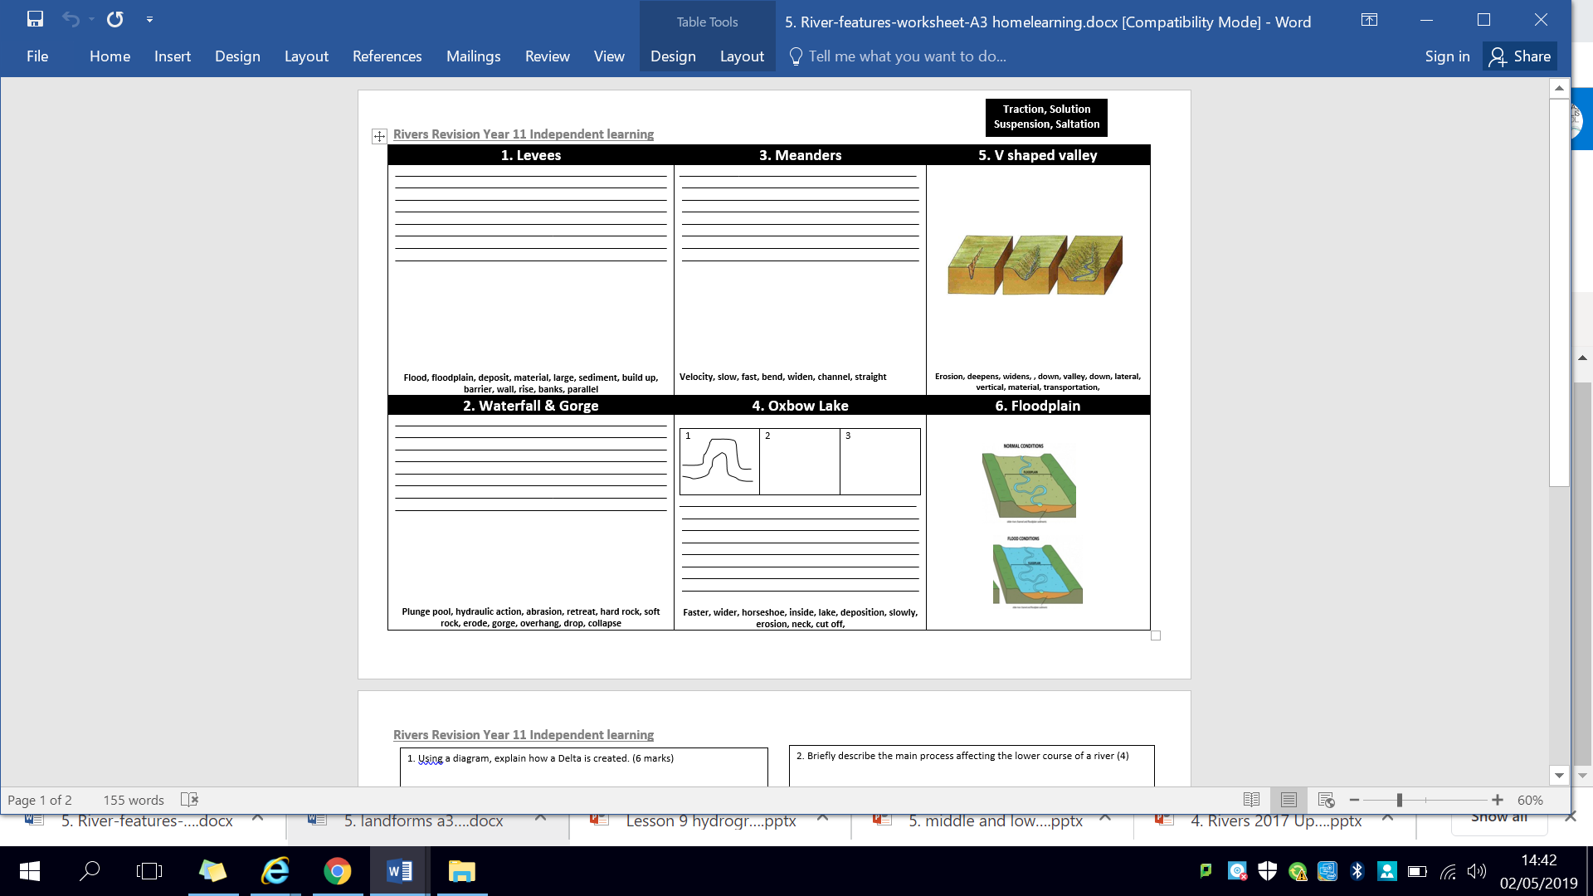

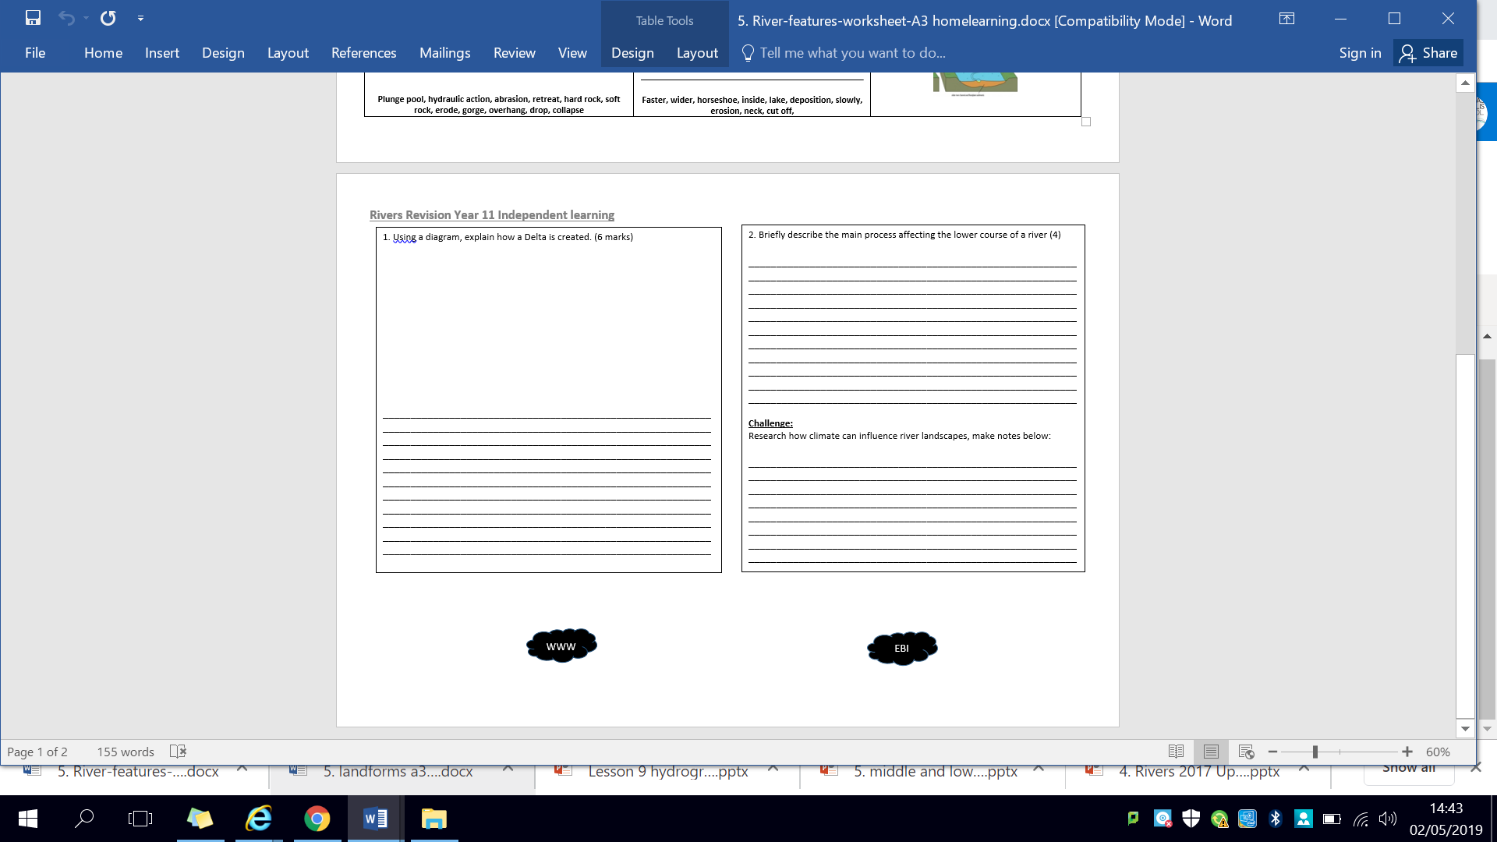

**Flood hydrographs**

1. 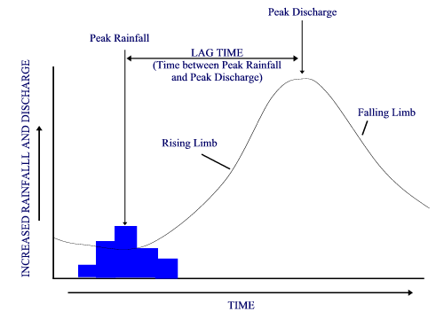Match up the key word with the correct definition.

|  |  |
| --- | --- |
| 1. Peak rainfall | 1. the takes time for the water to find its way to the river between peak rainfall and peak discharge |
| 1. Peak discharge | 1. Shows the amount of water (discharge) entering the river is increasing |
| 1. Lag time | 1. Shows the amount of water (discharge) in the river is decreasing |
| 1. Rising limb | 1. the time of highest rainfall |
| 1. Falling limb | 1. the time when the river reaches its highest flow |

If the rising limb is very steep, does this mean flooding is more or less likely? Why?

If the lag time is very short, does this mean flooding is more or less likely? Why?

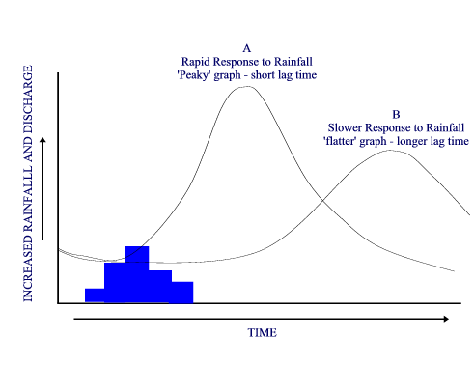

Explain the difference in lag time between A and B.

Give 3 reasons why lag time may be shorter for A.

Give 3 reasons why lag time may be longer for B.



Explain the difference in lag time between A and B.

Give 3 reasons why lag time may be shorter for A.

Give 3 reasons why lag time may be longer for B.

**River management**

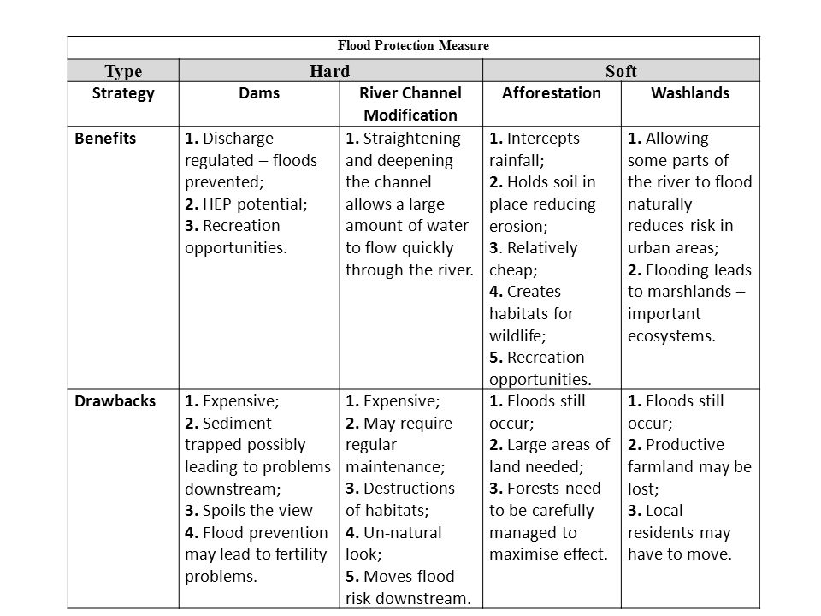

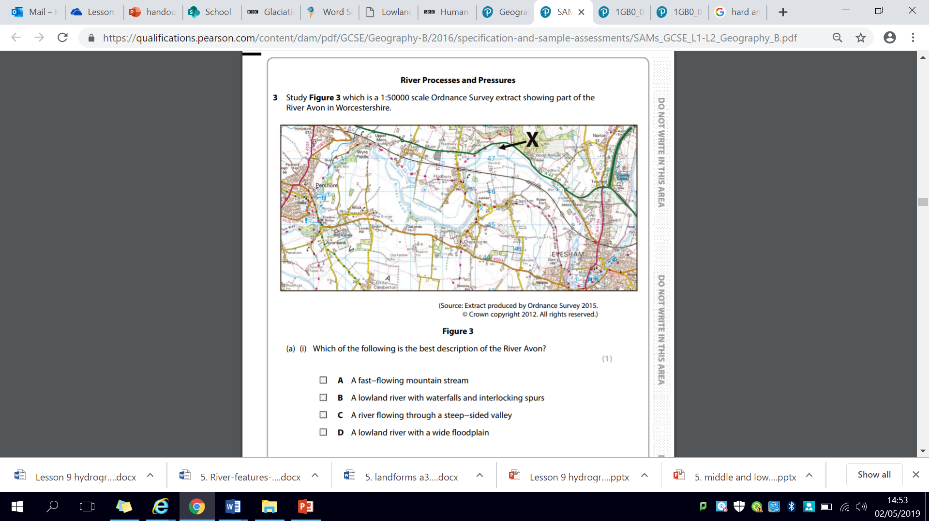

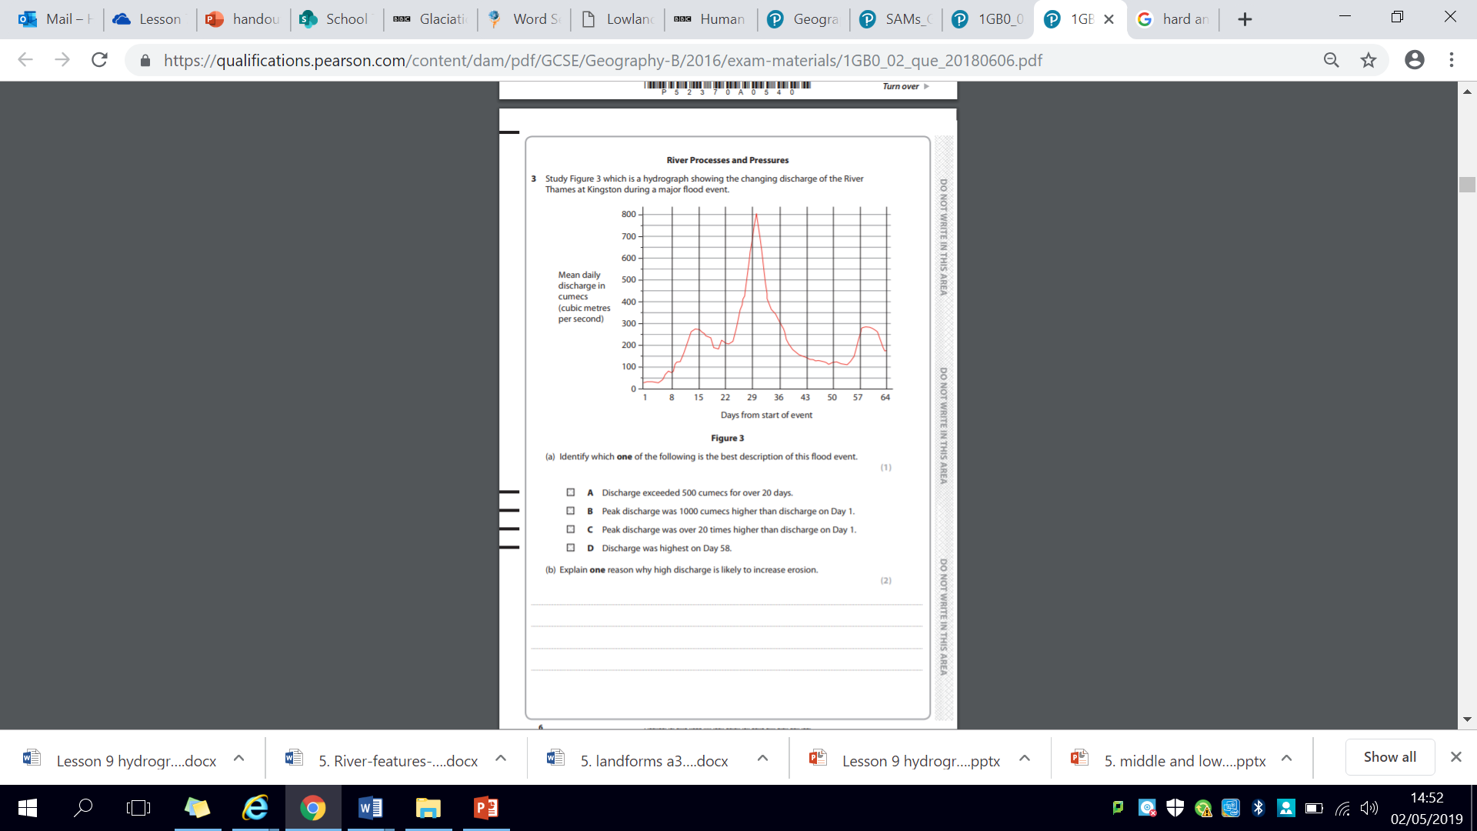

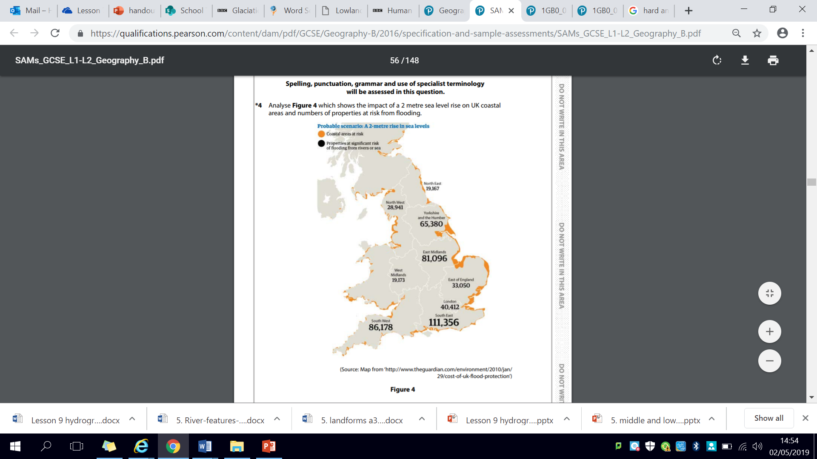

**Assess the physical and human factors which affect the pattern of UK properties at risk from flooding. (8+4)**

|  |
| --- |
| **Plan:** |

_________________________________________________________________________________________________________________________________________________________________________________________________________________________________________________________________________________________________________________________________________________________________________________________________________________________________________________________________________________________________________________________________________________________________________________________________________________________________________________________________________________________________________________________________________________________________________________________________________________________________________________________________________________________________________________________________________________________________________________________________________________________________________________________________________________________________________________________________________________________________________________________________________________________________________________________________________________________________________________________________________________________________________________________________________________________________________________________________________________________________________________________________________________________________________________________________________________________________________________________________________________________________________________________________________________________________________________________________________________________________________________________________________________________________________________________________________________________________________________________________________________________________________________________________________________________________________________________________________________________________________________________________________________________________________________________________________________________________________________________________________________________________________________________________________________________________________________________________________________________________________________________________________________________________________________________________________________________________________________________________________________________________________________________________________________________________________________________________________________________________________________________________________________________________________________________________________________________________________________________________________________________________________________________________________________________________________________________________________________________________________________________________________________________________________________________________________________________________________________________________________________________________________________________________________________________________________________________________________________________________________________________________

|  |  |
| --- | --- |
| **WWW** | **EBI** |
|  |  |