Name: ___________________________________

YEAR 11 Geography Revision work booklet
Revision pack 6:

Paper 2: UK Geographical Issues
The UK’s evolving human landscape

Key words
Complete the word search to identify key words for this topic.
BROWNFIELD | CBD | CDA | DATA | DECENTRALISATION
DE-INDUSTRIALISATION | DEPRIVATION | DIVERSIFICATION | ENVIRONMENTAL QUALITY INDEX | FDI
GENTRIFICATION | GLOBALISATION | GREENFIELD | INTERDEPENDENCE | LONDON
MARGINAL | MIGRATION | NETWORKS | PEDESTRIAN COUNT | POPULATION
PRIMARY | PRIVATISATION | QUALITATIVE | QUANTITATIVE | RANDOM
RENGENERATION | RURAL | SAMPLING | SECONDARY | SETTLEMENT
SITE | SITUATION | STRATIFIED | STUDENTIFICATION | SUSTAINABILITY
SYSTEMATIC | TNC | TRADE | URBAN

Key words and definitions:
Brownfield site
Carbon Footprint | Measurement of all the greenhouse gases an individual produces expressed as tonnes of carbon dioxide equivalent
Central Business District (CBD)
Comprehensive Development Areas (CDA) | Areas, usually in the inner city, where the whole urban landscape was demolished before being rebuilt on a planned basis.
Congestion
Conurbation | An area in which a number of existing urban areas have grown and merged into a single large urban area.
Counter- urbanisation
Decentralisation | The movement of people, factories, offices and shops away from city centres to suburban and edge of city locations
Degradation
De-industrialisation | The decline of industrial activity in a region or in an economy.
Economic core
Economic periphery | The edge of a country or region in terms of economics, a more remote area with fewer opportunities
Globalisation | The increasing interconnectedness and interdependence of the world economically, culturally and politically.
Index of multiple deprivation (IMD)
Infrastructure | The basic services such as roads and power supplies which are needed to keep a country or region running.
Migrate
Migration | The long term change in the Earth’s orbit that causes natural climate change.
Primary data
Primate city | The largest city in a country which dominates its economy, politics and often infrastructure.
Privatisation
Qualitative | Data without numbers based on people’s opinions or ideas, for example an interview or field sketch
Quantitative
Random sampling | Data that is collected so each has an equal chance of being selected, for example by using random numbers
Range
Regeneration | Reviving the economy or environment of a run-down area
Re-urbanisation
Rural-urban migration | The movement of people from the countryside to towns and cities.
Secondary data
Site | The actual location of a settlement on the earth, composed of the physical characteristics of the landscape specific to the area.
Situation
Stratified sampling | Data that is collected from different parts of a population, for example different age groups.
Suburbanisation
Sustainable | Able to continue without causing damage to the environment
Urban economy
Urbanisation

UK Human landscape
Study figure 1 the population of the UK.
Describe the population distribution of the UK (4)
_____________________________ _____________________________ _____________________________ _____________________________ _____________________________ _____________________________ _____________________________ _____________________________ _____________________________ _____________________________ _____________________________

Use the information below to improve your answer
Population density is highest in cities, e.g. London, Glasgow and Birmingham
It is also high in areas around major cities, or where major cities have developed into conurbations e.g. Liverpool.
Upland areas such as Northern Scotland and central Wales are mostly rural. Rural areas are sparsely populated.
Other rural areas include the south west and north of England and Northern Ireland.

Why would Urban cores have more economic activity than rural areas? (2)
_____________________________________________________________________________________________________________________________________________________________________________________________________________________________________________________________________________________________________________________________________________________________________________________________________________________________________________________________________________________________________________________________________________
Use the figure, describe the population structure of people over 65 years of age in England and Wales (4) _________________________________________ _________________________________________ _________________________________________ _________________________________________ _________________________________________ _________________________________________ _________________________________________ _________________________________________ _________________________________________ _________________________________________
Explain why urban cores have younger populations than the rural periphery (4) _____________________________________________________________________________________________________________________________________________________________________________________________________________________________________________________________________________________________________________________________________________________________________________________________________________________________________________________________________________________________________________________________________________
How does the UK and EU government aim to reduce the differences in wealth across the UK?
Enterprise zones | Enterprise Zones are designated areas across England that provide tax breaks and Government support. They are great places to do business especially for both new and expanding firms. Enterprise Zones are part of the Government's wider Industrial Strategy to support businesses and enable local economic growth. An example is the new Dorset Green enterprise zone with two high tech engineering companies and hopes to attract 55 more, creating 2000 new jobs in the region.
Transport infrastructure | The UK government plans to link London, Birmingham, Leeds and Manchester with a new high speed rail line, HS2. This will increase capacity and allow faster journeys into major cities – promoting industry and jobs in poorer rural areas in the north of England.  On a local scale, Lancashire county council has built a new road to link the port of Heysham in Lancashire to the M6. This will encourage businesses to invest by reducing travel times and easing congestion, creating more job opportunities for people in the surrounding rural areas.
Regional development | The EU has used European Regional Development Fund to promote growth in poorer rural areas by investing in small high-tech businesses, providing training to improve local people’s skills and funding infrastructure, e.g. high speed broadband to attract businesses. For example the EU funded superfast broadband in Cornwall. This attracts digital businesses, such as Gravitas, and links regeneration projects and new research and development centres in the region. This is creating skilled jobs in the area, attracting young graduates and boosting the local economy.

Using the information EU and UK governments in reducing wealth disparities across the UK complete the question below:
Explain two ways in which government policies can help rural areas to develop (4) ________________________________________________________________________________________________________________________________________________________________________________________________________________________________________________________________________________________________________________________________________________________________________________________________________________________________________________________________________________________________________________________________________________________________________________________________________________________
UK immigration policy has increased diversity
After the second world war, the UK encouraged immigration from Commonwealth countries e.g. the Caribbean, India and Pakistan, to fill skills shortages in the UK workforce.
Later, entry was restricted but work permits for migrants with desirable skills, e.g. IT were made available – many highly skilled Indians and Pakistanis still come to the UK.
This has meant that the UK has a high proportion of people of Caribbean and Asian ethnicity – nearly 10%.
Since 1995 the EU has allowed free movement of people within member countries to find work this increased the number of people migrating to the UK from Europe, e.g. from Germany.
In 2004 eight new countries joined the EU. Lots of people moved from these countries, e.g. Poland and Hungary, to find jobs in the UK. This was mainly in low-skilled jobs, eg.g catering and agriculture.
Between 2001 and 2011 the proportion of non-British white people increased more than any ethnic group – Polish people are now one of the largest non-UK born groups.
International immigration has increased cultural diversity, immigrants introduce languages, food, arts, festivals and fashion from their own culture giving the UK a rich mix.
Using the text: Explain how immigration has contributed to the diversity of the UK (4). __________________________________________________________________________________________________________________________________________________________________________________________________________________________________________________________________________________________________________________________________________________________________________________________________________________________________________________________________
Explain how migration has contributed to the UK economy (4) __________________________________________________________________________________________________________________________________________________________________________________________________________________________________________________________________________________________________________________________________________________________________________________________________________________________________________________________________
The UK economy
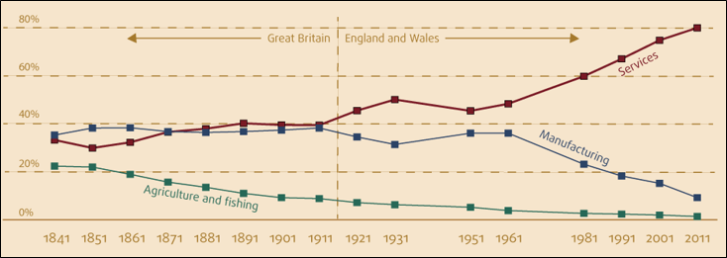
Most people work in manufacturing followed closely by services ​ | Over 1 in 5 workers worked in agriculture and fishing​ | The gap between services and manufacturing starts to widen at a faster rate than previously​
Over 8 in 10 workers were in the services sector with less than 1 in 10 in manufacturing​ | The percentage of workers in services overtakes those in manufacturing​ | At every census the percentage of people working in this industry declines​
World War II saw an increase in the percentage of manufacturing workers​ | Less than 1 in 100 people work in the agriculture and fishing industry​ | For this 60 year period the percentage of workers in the service industries increased at every census​
Using the graph and the information complete the following questions: Describe how UK employment structure has changed over time (4) _____________________________________________________________________________________________________________________________________________________________________________________________________________________________________________________________________________________________________________________________________________________________________________________________________________________________________________________________________________________________________________________________________________
Explain reasons for the changing UK employment structure (4) _____________________________________________________________________________________________________________________________________________________________________________________________________________________________________________________________________________________________________________________________________________________________________________________________________________________________________________________________________________________________________________________________________________
UK links with the wider world
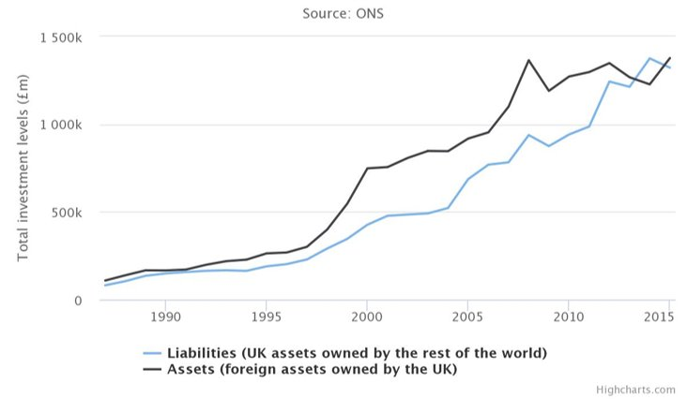
Keywords: ​ FDI - however – in addition – inflows – Trade - increase – decrease – peak – gradually – globalisation – investment – net –
Using the graph and the keywords describe how FDI in the UK has changed over time (2) ____________________________________________________________________________________________________________________________________________________________________________________________________________________________________________________________________________________________________________
Why has FDI increased in the UK?
Globalisation | The process of countries becoming more integrated. It is increasing FDI because: transport and communication links have improved making it easier for companies to operate in the UK. London has developed as a global financial centre – many foreign banks, e.g. the German Deutsche bank, have located here because of the business culture and networking opportunities.
Privatisation | Services that were previously run by the UK government have been offered to private firms. This has increased FDI because foreign firms can buy them or merge them with their existing businesses.
Free trade policies | Free trade policies reduce import and export restrictions, making it easier for countries to trade. Free trade is promoted between member countries of the EU. This increases FDI from the EU because companies can move goods and services freely between the UK and their home country. Free trade agreements with other countries can attract investors to the UK who want access to the European market a d often include special agreements for investment as part of the deal. Since the UK voted to leave the EU, the future of free trade policies in the UK is uncertain.

Explain two reasons why FDI is increasing in the UK (4) __________________________________________________________________________________________________________________________________________________________________________________________________________________________________________________________________________________________________________________________________________________________________________________________________________________________________________________________________
(a) Which of the following regions experienced the largest increase in population between 1981 and 2011? (1)
A South West
B West Midlands
C London
D Wales
(b) State two reasons why tertiary employment has increased in the UK. (2) ____________________________________________________________________________________________________________________________________________________________________________________________________________________________________________________________________________________________________________
(c) The population geography of the UK has been changed by internal migration in the past 50 years.
Explain one reason why some regions of the UK have experienced almost no population growth in the past 50 years. (2)
____________________________________________________________________________________________________________________________________________________________________________________________________________________________________________________________________________________________________________

