Name: ___________________________________

YEAR 11 Geography Revision work booklet
Revision pack 6:

Paper 2: UK Geographical Issues
Dynamic UK Cities

London boroughs
Annotate you map to show the different boroughs of London.
1: City | 10: Islington | 19: | 28:
2: Westminster | 11: | 20: | 29:
3: Kensington and Chelsea | 12: | 21: | 30:
4: Hammersmith and Fulham | 13: | 22: | 31:
5: | 14: | 23: | 32:
6: | 15: | 24: | 33: Hillingdon
7: | 16: | 25:Barking and Dagenham
8: Tower Hamlets | 17: | 26:
9: | 18: | 27:
London is a Global city in South East England
London is sited on the flat floodplain of the river Thames where it meets the sea.
It is the UK’s capital city and is an essential part of the UK’s economy, over 20% of the UK’s income comes from London.
It is the centre of the UK’s transport system. It was a major port until 1981 and still has global shipping links. There are 5 airports.
It has a major influence on its surrounding area. Companies are attracted to the region by the proximity to London, this increases jobs and wealth. The south East and East England are the two biggest regional economies in the UK outside of London.
London is important globally too, it is a world city and, along with New York, one of the two most important financial centres in the world. There are more foreign banks in London than anywhere else.

Read through the information above. Answer the following questions:
Describe the site of London (2) _________________________________________________________________________________________________________________________________________________________________________________________________________________________________
Describe the situation of London (2) _________________________________________________________________________________________________________________________________________________________________________________________________________________________________
Comparing London with the Burgess and Hoyt models
Geographers have put together models of land use to show how a 'typical' city is laid out. One of the most famous of these is the Burgess or concentric zone model.
This model is based on the idea that land values are highest in the centre of a town or city. This is because competition is high in the central parts of the settlement. This leads to high-rise, high-density buildings being found near the Central Business District (CBD), with low-density, sparse developments on the edge of the town or city.
Hoyt Model
Burgess Model
However, London is better represented by the Hoyt model. This is based on the circles in the Burgess model, but adds sectors of similar land uses concentrated in parts of the city. Notice how some zones, e.g. the factory/industry zone, radiate out from the CBD. This is usually following the line of a main road or a railway. In London, the River Thames became central to industry. Therefore, working class housing was developed along the river, moving eastwards from the CBD.
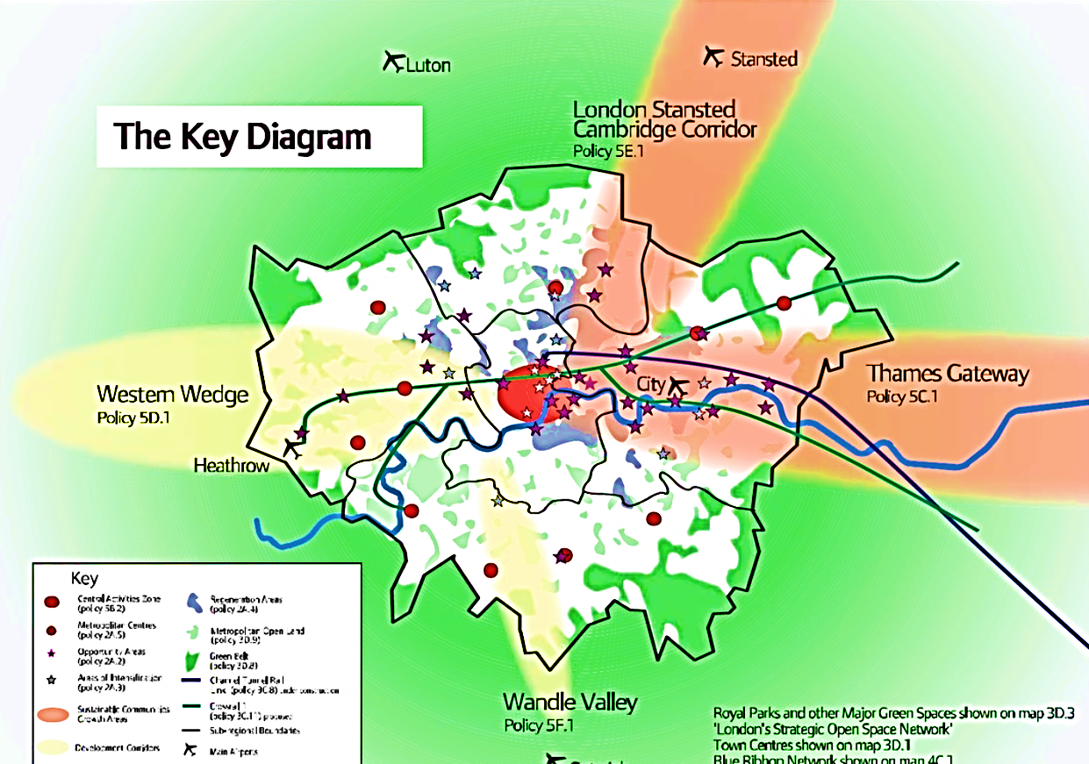
Study the diagram below
Suggest which model of Land use London is similar to. Give reasons for your answer.
___________________________ ___________________________ ___________________________ ___________________________ ___________________________ ___________________________ ___________________________ ___________________________ ___________________________ ___________________________
Describe the changes in London’s population over time (4) ___________________________ ___________________________ ___________________________ ___________________________ ___________________________ ___________________________ ___________________________ ___________________________ ___________________________ ___________________________
Describe the changes in population throughout the London boroughs (4) ______________________ ______________________ ______________________ ______________________ ______________________ ______________________ ______________________ ______________________ _________________________________________________________________________________________________________________________________________________________________________________________________________________________________
These changes in population are the result of the changes in the economic structure of London. For example, as the docks closed, manufacturing was lost, particularly in the Lea Valley. This led to many job losses in inner London and migration out of the city, resulting in a loss of population in inner London.
Since 1981, the number of jobs in financial services and knowledge-based industries has increased. In addition, the redevelopment of London’s docklands (through the London Docklands Development Corporation) in the 1990s, and the more recent redevelopment of the Olympic site in East London, increased the number and variety of jobs available in London, making it a desirable place to live. As a result, the population of both inner and outer London has risen.

Suggest one reason why population has decreased in some London boroughs (2) ____________________________________________________________________________________________________________________________________________________________________________________________________________________________________________________________________________________________________________
Suggest one reason why population has increased in some London boroughs (2) ____________________________________________________________________________________________________________________________________________________________________________________________________________________________________________________________________________________________________________
- (i) Study Figure 6. Identify the modal class for work day males. (1)
A 16
B 31
C 43
D 61
(ii) Identify one age group for which the work day female and resident female population is the same. (1)
______________________ ______________________ ______________________

The structure of London
Area of London | Building age | Building density | Land uses | Environmental Quality
CBD  (City – central London) | Oldest buildings in the city of London | High density – lots of buildings, high rises very expensive | Offices, retail, non-residential | Relatively high due to royal parks e.g. Hyde park
Wealthier inner suburbs  (Kensington/Notting Hill) | 18th/19th century  used for gentry to be close to the city | Medium/high | Residential terraced housing, parks | Smart, clean, green, e.g. Kensington and Notting Hill
Poorer inner suburbs  (Hackney/ Stratford) | 18th/19th century | High (some suburbs are going through a process of regeneration e.g. Hackney | Factories and residential terraced housing, although factories closed due to deindustrialisation | Low, factories have been abandoned and there are a lot of brownfield sites
Outer suburbs  (Loughton) | Late 20th century | Lower more open space, no high rise buildings | Houses 2 story with gardens, some industry on outskirts | High, open green spaces such as Epping forest and homes have large gardens

Does London have more than one CBD?
Traditionally London’s CBD is the oldest part of the city, it is the most accessible part of London and is right in the centre of London. However London is continually growing.
The CBD has expanded, it now includes new buildings such as the Shard.
Canary Wharf (the old docklands) has undergone regeneration, massive investment in the docks has changed the function of the area from old factories that had shut down, to a new modern CBD focused on the Knowledge economy. This new CBD is still being built and has many of the financial businesses headquarters there. It is 4km east of the City CBD and is now London’s’ second CBD.
London’s ‘West End’ – its shopping streets (e.g. Oxford Street) and theatreland form the third CBD for London.
State two characteristics of a Central Business District (CBD). (2) _________________________________________________________________________________________________________________________________________________________________________________________________________________________________
State two characteristics of the outer suburbs (2) _________________________________________________________________________________________________________________________________________________________________________________________________________________________________

