Name: ___________________________________

YEAR 11 Geography Revision work booklet
Revision pack 6:

Paper 2: UK Geographical Issues
Dynamic UK Cities

London and migration
Most migrants to London are working age adults between 21 and 35 years old. Internal migration from within the UK consists of mostly recent graduates from UK universities seeking work and a London lifestyle, International migration consists of two groups of workers – skilled and unskilled.
Skilled workers take up well paid jobs in the knowledge economy. These workers tend to be highly qualified professionals from the EU, USA, South Africa and Australia. This is because the UK does not have enough skilled workers to fill all of the jobs.
Unskilled workers often do jobs that UK residents do not want to do e.g. refuse collection, pizza delivery and cleaning. London staffs much of its construction and hotel, restaurant services with unskilled workers. They come from the EU, India, Pakistan, Bangladesh and West Africa.
This map shows the largest foreign born populations in London by borough.
What foreign nationality is the most common in London? _________________ Give one reason to suggest why this nationality settles in London (e.g. no language barrier, EU country, Commonwealth etc) _________________ _________________ _________________ _________________ _________________ _________________ _________________ _________________

A map to show the percentage distribution of White British people living in London.
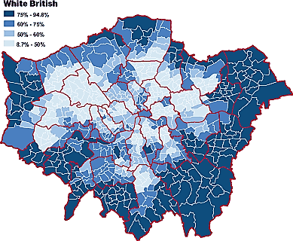
Look at the map. Suggest trends or patterns that you can see when looking at White British people living in London.
Suggest why the outer suburbs of London have more white British than inner suburbs (4) _______________________________ _______________________________ _______________________________ _______________________________ _______________________________ _______________________________

How Migration affects three London suburbs
 | Newham | Lambeth | Richmond upon Thames
Ethnicity | One of London’s most diverse boroughs, 30% white, 26% black Caribbean and African, 39% Asian | Diverse 38% born outside of the UK from 152 countries Black 25%, White 55%, small Asian population 8% | One of the least diverse boroughs in London 85% white, 7% Asian. Many of the white population were born overseas – from the EU or USA
Income | Low income area | Average income area | Very high income area
Housing | Mostly rented 32% own a property 35% rent privately 32% rent from social housing | 44% own a property, 20% rented privately 34% rented from social housing | 69% own a property, 16% rent privately, 15% rent from social housing
Services | Schools under pressure caused by high birth rate. Pressure on social services with 38% of children living in poverty | 81% of children in schools from ethnic backgrounds. 140 languages spoken in Lambeth schools. English is a second language in 50% of school students. | Less pressure on schools with fewer children, higher than average percentage of children in care homes.
Culture | Mainly Asian with several temples, mosques, churches. Asian food shops and small businesses | Varies from black Caribbean culture – food markets and restaurants to white middle class | Predominantly white middle class.

Assess the impacts of the variations in ethnic group distribution of London boroughs (8)
________________________________________________________________________________________________________________________________________________________________________________________________________________________________________________________________________________________________________________________________________________________________________________________________________________________________________________________________________________________________________________________________________________________________________________________________________________________________________________________________________________________________________________________________________________________________________________________________________________________________________________________________________________________________________________________________________________________________________________________________________________________________________________________________________________________________________________________________________________________________________________________________________________________________________________________________________________________________________________________________________________________________________________________________________________________________________________________________________________________________________________________________________________________________________________________________________________________________________________________________________________________________________________________________________________________________________________________________________________________________________________________________________________________________________________________________________________________________________________________________________________________________________________________________________________________________________________________________________________________________________________________________________________________________________________________________________________________________________________________________________________________________________________________________________________________________________________________________________________________________________________________________________________________________________________________________________________________________________________________________________________________________________________________________________________________________________________________________________________________________________________________________________________________________________________________________________________________________________________________________________________________________________________________________________________________________________________________
London’s inequalities
Multiple deprivation is an overall score based on income, housing, health and services.
The darker the shade, the more deprived the area. What does it tell you about London?
State where the most and least deprived areas of London are? (Try to use borough names, compass directions and N/S of the river) _______________________________________________________________________________________________________________________________________________________________________________________________________________________________________________________________________________________________________________________________________________________________________________________
Newham | Richmond upon Thames
One of London’s most deprived boroughs  Low income = more children on free school meals.  Poor health – long term limiting illnesses = limits availability to work and earn money  Percentage of 19 year olds without qualifications is high – however Newham has invested heavily into education to improve schools, as a result students gaining GCSE results has increased. | One of London’s wealthiest boroughs  High incomes as people have degrees allowing them to gain employment with greater incomes.  Better health – steady employment  Percentage of 19 year olds without qualifications is similar to Newham. With school improvements in Newham they will likely overtake Richmond in reducing the percentage of 19 year olds without GCSEs.

What happened to London in the 80s?
Deindustrialisation | Suburbanisation | Decentralisation
The London docks closed in 1981 due to the use of container ships (containerisation) needing deeper ports away from the city.  Factories in the area closed as they relied on the ports  Unemployment in the East London increased so people moved out of the area to look for jobs. | People moved out of the city where housing is smaller and older, moving to cheaper larger homes in the outer suburbs with gardens. This was due to the expansion of transport networks in London allowing people to commute into the city from further away. | With more people moving to the suburbs, more shops and services were needed there. This lead to out of town shopping centres, retail parks and business parks. E-commerce (buying online) also meant that people did not need to come into the city for shopping or entertainment.

Explain why many UK cities are experiencing more growth at their edges than in their centres (4) _______________________________________________________________________________________________________________________________________________________________________________________________________________________________________________________________________________________________________________________________________________________________________________________
Expansion and regeneration in London
Since 1991, the flow of people leaving London has reversed. Re-urbanisation has taken place. These are the 4 main factors leading to growth:
Space | Investment | Gentrification | Studentification
Redevelopment of brownfield sites e.g. docklands into new housing and offices | From large TNCs creates jobs in the financial and business services e.g. Canary Wharf | High income earners want to live closer to work than commute, many former working class inner suburb areas e.g. Fulham have become gentrified – occupied and invested in by middle classes. | University expansion has been caused by a demand from overseas students. Universities impact communities e.g. Queen Mary University in East London have increased student populations in the area increasing student spending in the area.

The impacts of rebranding London
Stratford in the Lower Lea Valley lies to the north of the London Docklands. It had one of the most deprived communities in the country, where unemployment was high and levels of health were poor. There was a lack of infrastructure and the environmental quality was poor. The 2012 London Olympics bid was partly successful on the understanding that Stratford would be used during the games and regenerated for local people to use after the competitors had left. After the Olympic Games were over, the park was named the Queen Elizabeth Olympic Park.
Benefits of rebranding and regeneration in East London due the Olympic legacy?
Social | Economic | Environmental
By 2030, more than 10,000 new homes will have been built in the park. Five new neighbourhoods, with lots of green spaces planned in, will be built and around a third of those houses will be affordable. A new academy has been built which is used to educate around 2,000 pupils between the ages of 3-18 | Stratford is now a well-connected area of London, which allows commuters to travel to work easily. New jobs in construction and tourism have created a multiplier effect. It is estimated that over 20,000 jobs could be created by 2030, bringing more than £5 billion into the area. | The Olympic bid was partly successful on the basis of sustainability. The park is sustainable in a number of ways, eg walking and cycling routes, the provision of public transport, the water-efficient design of homes and the protection of green spaces and natural habitats.

Explain how the Olympic park has regenerated East London (4) _______________________________________________________________________________________________________________________________________________________________________________________________________________________________________________________________________________________________________________________________________________________________________________________

Sustainable London?
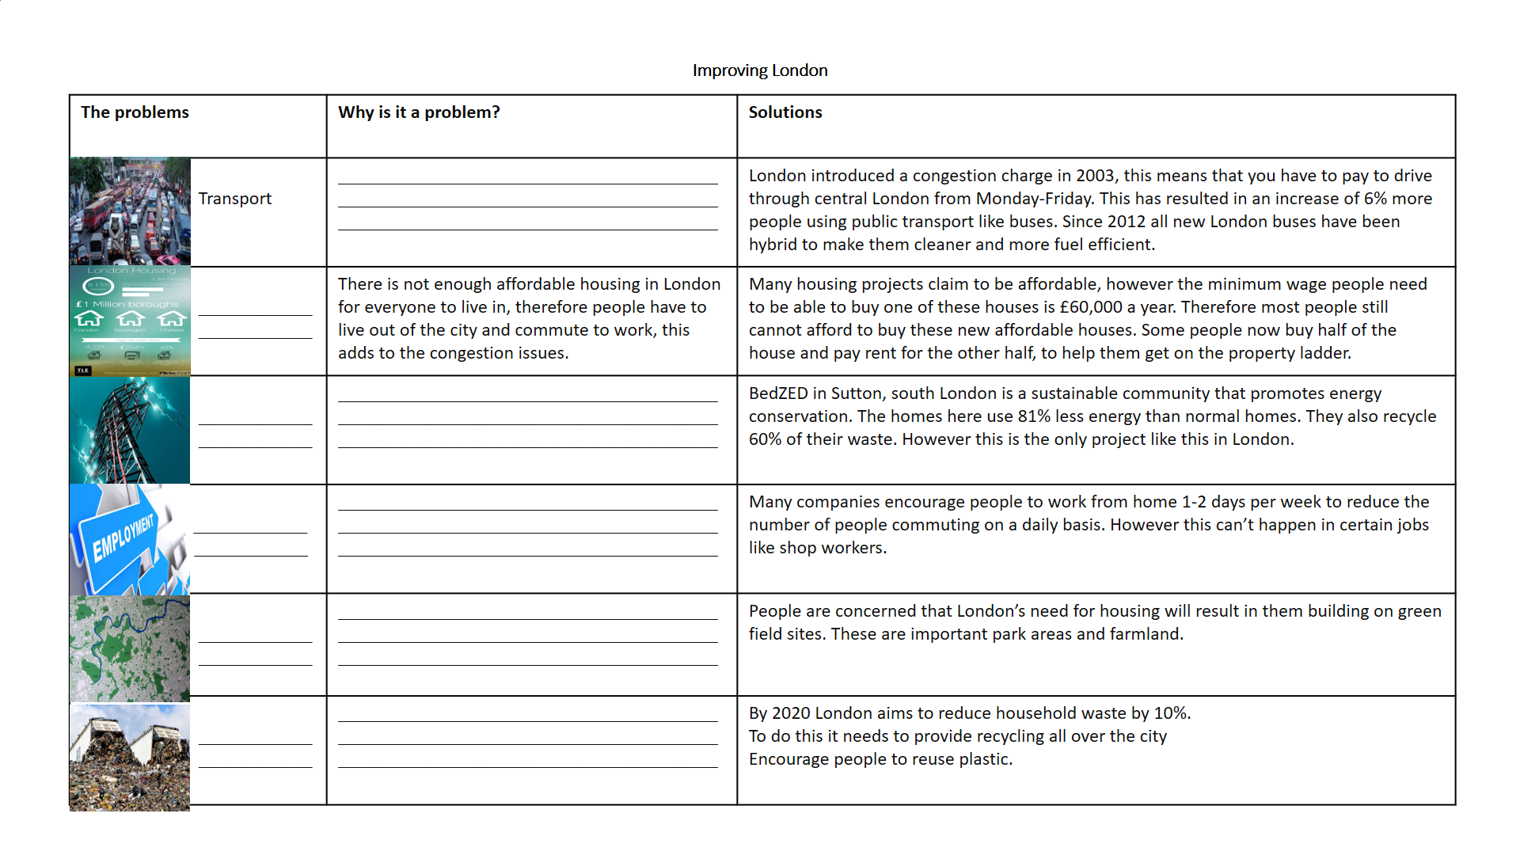
Improving London Exam question: Evaluate the success of strategies aimed at making urban living more sustainable (8)
Read through the answer, what mark do you think this got?
London has introduced a congestion charge in 2003 to charge people driving in central London and reduce the number of cars driving through. It also increased funding for public transport. This has resulted in a 6% increase in people using public transport in London and a drop in cars travelling through central London. However more people have moved into the city since and therefore the number of cars has increased, meaning congestion is still an issue.
Furthermore London has tried to encourage companies to allow for employers to work from home to reduce commuting into the city. This has increased people working from home from 4.3% to 8.6%, but this is not suitable for people working in shops.
Overall strategies have been successful however they need to be sustained and improved further to make a greater impact long term.
MARK SCHEME
1-2 marks – basic ideas of problems with 1 idea of improvement
3-4 marks – basic ideas of problems with 2 ideas of improvements linked to success.
5-6 marks – clear ideas of problems using a case study with linked strategies for improvements, some ideas of how successful a strategy has been.
7-8 marks – clear problems using a case study with linked detailed strategies for improvements and an overall conclusion to how successful each strategy was
WWW | EBI

The rural fringe of London
